Client Application of caBench-to-Bedside v3.1
End User Manual
Document Change History

Version Number | Date | Contributor | Description
V1.0 | July 12, 2007 | Washington University/ Persistent Systems | Reviewed
V2.0 | June 9, 2008 | Washington University/ Persistent Systems | Reviewed
V2.1 | December 4, 2008 | Washington University/ Persistent Systems | Reviewed
V2.1 | December 23, 2008 | Washington University/ Persistent Systems | Reviewed by Documentation and Training workspace
V3.0 | June 17,2009 | Washington University/ Persistent Systems | Reviewed
V3.0 | July 24,2009 | Washington University/ Persistent Systems | Addressed comments by Documentation and Training workspace
V 3.1 | September 10, 2009 | Washington University/ Persistent Systems | Draft
V 3.1 | September 12, 2009 | Washington University/ Persistent Systems | Review



This is a U.S. Government work. September 15, 2009

Development Teams
Development | End User Manual | Program Management
Chandrakant Talele¹ | Chandrakant Talele¹ | Dr. Rakesh Nagarajan²
Chetan Patil¹ | Madhumita Shrikhande¹ | Srikanth Adiga^{1, 2}
Chetan Pundhir¹ | Pooja Arora¹
Deepak Shingan¹ | Srikanth Adiga^{1,2}
Gaurav Mehta¹ | Mukesh Sharma²
Pallavi Mistry¹
Rajesh Vyas¹
¹Persistent Systems Limited | ²Washington University

Contacts and Support
Training contact | cab2bsupport@bmi.wustl.edu
Customer support contact | cab2bsupport@bmi.wustl.edu

Copyright and License Information

Copyright Notice. Copyright 2005 “School of Medicine, Washington University in St. Louis” (“caBIG® Participant”). cancer Bench-to-Bedside was created with NCI funding and is part of the caBIG® initiative. The software subject to this notice and license includes both human readable source code form and machine readable, binary, object code form (the “caBIG® Software”).
This caBIG® Software License (the “License”) is between caBIG® Participant and You. “You (or “Your”) shall mean a person or an entity, and all other entities that control, are controlled by, or are under common control with the entity. “Control” for purposes of this definition means (i) the direct or indirect power to cause the direction or management of such entity, whether by contract or otherwise, or (ii) ownership of fifty percent (50%) or more of the outstanding shares, or (iii) beneficial ownership of such entity.
License. Provided that You agree to the conditions described below, caBIG® Participant grants You a non-exclusive, worldwide, perpetual, fully-paid-up, no-charge, irrevocable, transferable and royalty-free right and license in its rights in the caBIG® Software, including any copyright or patent rights therein that may be infringed by the making, using, selling, offering for sale, or importing of caBIG® Software, to (i) use, install, access, operate, execute, reproduce, copy, modify, translate, market, publicly display, publicly perform, and prepare derivative works of the caBIG® Software; (ii) make, have made, use, practice, sell, and offer for sale, and/or otherwise dispose of caBIG® Software (or portions thereof); (iii) distribute and have distributed to and by third parties the caBIG® Software and any modifications and derivative works thereof; and (iv) sublicense the foregoing rights set out in (i), (ii) and (iii) to third parties, including the right to license such rights to further third parties. For sake of clarity, and not by way of limitation, caBIG® Participant shall have no right of accounting or right of payment from You or Your sublicensees for the rights granted under this License. This License is granted at no charge to You. Your downloading, copying, modifying, displaying, distributing or use of caBIG® Software constitutes acceptance of all of the terms and conditions of this Agreement. If you do not agree to such terms and conditions, you have no right to download, copy, modify, display, distribute or use the caBIG® Software.
- Your redistributions of the source code for the caBIG® Software must retain the above copyright notice, this list of conditions and the disclaimer and limitation of liability of Article 6 below. Your redistributions in object code form must reproduce the above copyright notice, this list of conditions and the disclaimer of Article 6 in the documentation and/or other materials provided with the distribution, if any.
- Your end-user documentation included with the redistribution, if any, must include the following acknowledgment: “This product includes software developed by School of Medicine, Washington University in St. Louis.” If You do not include such end-user documentation, You shall include this acknowledgment in the caBIG® Software itself, wherever such third-party acknowledgments normally appear.
- You may not use the names “School of Medicine, Washington University in St. Louis”, “The National Cancer Institute”, “NCI”, “Cancer Bioinformatics Grid” or “caBIG®” to endorse or promote products derived from this caBIG® Software. This License does not authorize You to use any trademarks, service marks, trade names, logos or product names of either caBIG® Participant, NCI or caBIG®, except as required to comply with the terms of this License.
- For sake of clarity, and not by way of limitation, You may incorporate this caBIG® Software into Your proprietary programs and into any third party proprietary programs. However, if You incorporate the caBIG® Software into third party proprietary programs, You agree that You are solely responsible for obtaining any permission from such third parties required to incorporate the caBIG® Software into such third party proprietary programs and for informing Your sublicensees, including without limitation Your end-users, of their obligation to secure any required permissions from such third parties before incorporating the caBIG® Software into such third party proprietary software programs. In the event that You fail to obtain such permissions, You agree to indemnify caBIG® Participant for any claims against caBIG® Participant by such third parties, except to the extent prohibited by law, resulting from Your failure to obtain such permissions.
- For sake of clarity, and not by way of limitation, You may add Your own copyright statement to Your modifications and to the derivative works, and You may provide additional or different license terms and conditions in Your sublicenses of modifications of the caBIG® Software, or any derivative works of the caBIG® Software as a whole, provided Your use, reproduction, and distribution of the Work otherwise complies with the conditions stated in this License.
- THIS caBIG® SOFTWARE IS PROVIDED "AS IS" AND ANY EXPRESSED OR IMPLIED WARRANTIES (INCLUDING, BUT NOT LIMITED TO, THE IMPLIED WARRANTIES OF MERCHANTABILITY, NON-INFRINGEMENT AND FITNESS FOR A PARTICULAR PURPOSE) ARE DISCLAIMED. IN NO EVENT SHALL THE SCHOOL OF MEDICINE, WASHINGTON UNIVERSITY IN ST. LOUIS OR ITS AFFILIATES BE LIABLE FOR ANY DIRECT, INDIRECT, INCIDENTAL, SPECIAL, EXEMPLARY, OR CONSEQUENTIAL DAMAGES (INCLUDING, BUT NOT LIMITED TO, PROCUREMENT OF SUBSTITUTE GOODS OR SERVICES; LOSS OF USE, DATA, OR PROFITS; OR BUSINESS INTERRUPTION) HOWEVER CAUSED AND ON ANY THEORY OF LIABILITY, WHETHER IN CONTRACT, STRICT LIABILITY, OR TORT (INCLUDING NEGLIGENCE OR OTHERWISE) ARISING IN ANY WAY OUT OF THE USE OF THIS caBIG® SOFTWARE, EVEN IF ADVISED OF THE POSSIBILITY OF SUCH DAMAGE.

Contents
About This Guide 1
Purpose 1
Typical User 1
Topics Covered 1
Text Conventions Used 2
Chapter 1 Introduction 3
Conducting Research using caB2B 3
Getting started with caB2B 4
Starting the Application 4
Types of User 4
Secure and Non-Secure Data 6
Links on Home Page 7
Popular Categories 8
Overriding Administrator-defined Services 9
Understanding Categories and Limits 11
What is a Category? 11
Why do we need categories? 11
What is a Multi-model Category (MMC)? 11
What is a Limit? 12
What is a Query? 12
Chapter 2 Searching Data 13
Search data – The Query Wizard 13
Choose Search Category 14
Advanced Search 15
Define Limit 16
Steps for defining a limit 17
Limit Set – Diagrammatic View 18
DAG Operations 19
Connecting the Limits 20
The Information Panel 23
Reset, Previous and Next Buttons 24
Define Search Results View 24
The Next, Previous, Save Query and Service URL Buttons 25
Configuring Services for a Query 25
DCQL Viewer 28
Save Query 29
Why to Save Query? 29
Types of Saved Queries: 30
How to Save Query? 30
Executing a Saved Query 32
View Search Results 34
Record Details 35
The Next, Previous and Save Query Buttons 40
Group Results by Service URL 40
Viewing and Saving Data List 42
Operations on the Data List 44
Chapter 3 Experiments 46
What are Experiments and Projects? 46
Creating an Experiment 46
Viewing the Existing Experiments 48
Opening an Experiment 49
Working with an Experiment 50
The Operations panel 50
Visualization panel 50
Filtering Data 51
Custom Data Category 54
Visualizing Data 56
Text-based Search - For category name information 60
Text-based Search - For category and attribute name and description 61
Concept Code Based Search - For category name information 62
Concept code based search - For attribute name information 63
Administrator defined categories 67
Using the Range Filter 69
Using the Pattern Filter 70
Using the Enumerated Values Filter 70
Index 71

About This Guide
This section introduces you to caBench-to-Bedside Client Application 3.1. Topics in this section include
- Purpose
- Typical User
- Topics Covered
- Text Conventions Used

Purpose
cancer Bench-to-Bedside (caB2B) is an application that leverages caBIG® tools in a user-friendly graphical user interface (GUI). caB2B is a tool that provides a platform for querying all caBIG tools. The physician scientist can use caB2B to query any caGrid data service to obtain data, and save this data for further downstream analyses. For example, a physician can look for a specimen of interest from a tissue banking software and a lab scientist can find all the microarray experiments done on the same specimen from a microarray repository.
This manual provides the details of how to use caB2B application to search data sets of interest, create an experiment from data sets, analyze data, and visualize data.
The technical staff can install the caB2B application using the instructions provided in the caB2B installation guide. The Client Application accesses the caB2B server, installed by the technical staff. To start Client Application, refer to the caB2B Installation Manual’s Accessing the caB2B Application section. It is a java-based application. The application is installed on the user’s machine when the user accesses it for the first time.
All the chapters in this user’s manual start with an introductory statement followed by a list of topics included in that chapter.

Typical User
A typical user of the caB2B application would be a translational research scientist. The term translational research means research which typically begins at “the bench” with basic research — in which scientists study disease at a molecular or cellular level — then progress to the clinical level, or the patient's “bedside.” As this application supports the research at the bench as well as at the bedside, scientists would be the typical users.
The user should have the basic computer skills, like running java applications. The user should also be aware of caBIG and its tools. The user should have knowledge of UML models/domain models of the caBIG tools. Awareness of the domain model is required to create and execute the queries using caB2B.

Topics Covered
- Chapter 1: Introduction explains the scope and function of caB2B
- Chapter 2: Searching Data describes process of retrieving data by building metadata based queries
- Chapter 3: Experimentsexplains how to create and use virtual experiments using the searched data
- Appendix A: Examples of category search
- Appendix B: Define Limit: Operators and Values
- Appendix C: Record Details View
- Appendix D: Types of Filters

Text Conventions Used
This section lists the conventions used in this guide. The various typefaces represent interface components, keyboard shortcuts, toolbar buttons, dialog box options, and text that you type.
Convention | Description | Example
Bold | Highlights names of option buttons, check boxes, drop-down menus, menu commands, command buttons, or icons | Click Search.
Underlined Blue Text | Indicates a Web or e-mail address | http://domain.com
text in Small Caps | Indicates a keyboard shortcut | Press Enter
text in Small Caps + text in Small Caps | Indicates keys that are pressed simultaneously | Press Shift + Ctrl
Italics | Highlights references to other documents, sections, figures, and tables | See Figure 4.5.
Italic boldface monospace type | Represents text that you type | In the New Subset text box, enter Proprietary Proteins.
Note: | Highlights information of particular importance | Note: This concept is used throughout this document
{ } | Surrounds replaceable items | Replace {last name, first name} with the Principal Investigator’s name

Introduction
This chapter explains the scope and function of the cancer Bench to Bedside (caB2B) application. It helps you understand how to use caB2B to satisfy diverse biomedical research needs.
This chapter contains the following topics:
- Conducting Research using caB2B
- Getting started with caB2B
- Starting the Application
- Understanding Categories and Limits

Conducting Research using caB2B
The National Cancer Institute cancer Biomedical Informatics Grid® (NCI caBIG®) project creates a common, extensible informatics platform that integrates diverse data types and supports interoperable analytic tools. caBIG® is developing separate applications that will facilitate individual steps involved in micro-array analysis. These applications are also useful to bioinformaticians.
caGrid is the infrastructure for caBIG that helps integrate these applications. caGrid helps to perform investigation involving data integration and analytical services from diverse research communities.
cancer Bench-to-Bedside (caB2B) is an application that leverages these tools in a user-friendly graphical user interface (GUI). The physician scientist can use caB2B to perform operations such as:
- Query any caGrid data service to obtain data
The data service can be a single data service, multiple data services, or a combination of the two services using semantically interoperable Common Data Elements (CDEs).
For example, caB2B allows investigators to query tissue banks at multiple cancer centers, design studies that focus on very specific tumor subtypes and to target less common tumors by pooling bio-specimen resources. This alleviates the problem of small sample size in a study.
- Collect data and create experiments
caB2B also enables investigators to perform novel in silico experiments using archived microarray data sets. These capabilities facilitate identifying genes that are up or down regulated in specific cancers with respect to normals and enable investigators to view the data in the context of biological pathways. Investigators gain further understanding of the complex system of cancer biology by identifying genes that are important to the development and treatment of cancer. These capabilities may lead to effective identification of novel drug targets and improved treatment strategies.
- Perform analyses by using various grid-enabled analytical services.
caB2B enables individual users to work on common platforms to access caGrid resources in real time from common data and analytical services.
- Visualize analysis results by using charts and dendrograms.

Getting started with caB2B
caB2B provides a platform to bring the laboratory research to the clinical level. It enables information sharing along with the continuum from the scientific bench to the clinical bedside and back. The tool helps in querying various caGrid enabled services. For example, it is possible to query for all the up-regulated and down-regulated genes of a malignant tissue sample by using the services available in caB2B. Thus, it helps bridge the gap between the bench and the bedside. caB2B consist of a caB2B Client Application, caB2B Administrative Module and caB2B Web Application. The Administrative Module allows administrator to configure caB2B Client Application where the administrator can load models from caDSR, configure service URL’s create customized categories, create intermodel joins, and curate the paths.
- To configure Client and the Web Application refer to caB2B Administration Manual.
- To start caB2B Application, refer to the Installation Manual.
- To search for data sets, refer to “Search data – The Query Wizard”.
- To design experiments, refer to “Experiments”.

Starting the Application
Before you start the Client Application, the technical staff should have installed the caB2B application and the administrator should have configured the application using the administrative module. To access the Client Application you need to access the caB2B web page or download the caB2B client setup. For details on installing and starting the caB2B Client Application, refer to Accessing the caB2B Application section in the caB2B Installation Manual.
Once you install the Client Application using the web-start option, it creates an icon on users desktop. Next time you need to double-click the icon to start the application.

Types of User
The application supports two user roles – Anonymous User and caGrid User. You can search for data without signing in, although only publically available data is available. All such users who are querying for data without signing in are Anonymous Users.
The other type of user is caGrid User. These users are the ones who sign into the application using their production caGrid credentials. Currently, caB2B supports all the production grid users having a Dorian Identity Provider. A user can obtain a caGrid account by accessing the following URL and creating an account (https://cagrid-portal.nci.nih.gov/web/guest/register). When caB2B application starts, you see the caB2B Login page as shown in Figure 1.1.Error: Reference source not found
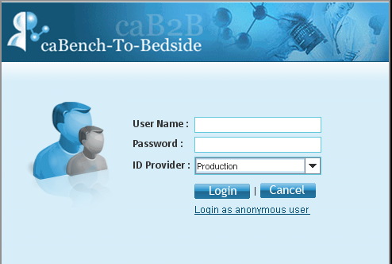
Figure 1.1. caB2B Login Page
To access the Client Application, you can login using your caGrid credential or use application as an anonymous (without grid credentials) user.
To login using your caGrid credentials, follow the steps given below:
- Type the User Name and Password.
- Select an ID Provider from the dropdown.
- Click Login to start the application.
Application will authenticate you using entered credentials. On successful authentication, you will see application home page. If authentication is unsuccessful, application will show an error message as shown in Figure 1.2.
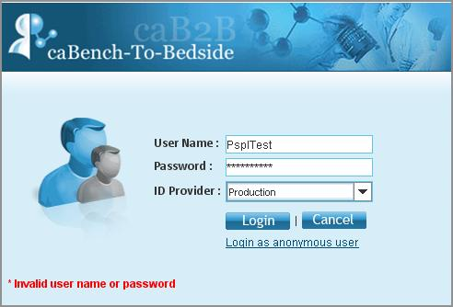
Figure 1.2. Login Error
If you do not have a caGrid account then you can log in as an anonymous user. While using anonymous user login you can only access public data and not the secured data that essentially requires caGrid credentials. It means that you would not be able to see data from any of the secured service like caTissue.
 | The anonymous user’s data is not secure.  Any user who logs in using the anonymous users link can access it.

Secure and Non-Secure Data
Data on caGrid can be categorized into two types, non-secure data i.e. publically available data and secure data i.e. data that requires authentication for access. Biological data may contain certain protected health information (PHI data). Only an authenticated user should have access to this secure data.
Microarray data available in caArray is an example of non-secure data, whereas biospecimen data available in caTissue is secure data.
When the caB2B application starts, you see the caB2B Home page as shown in Figure 1.3.
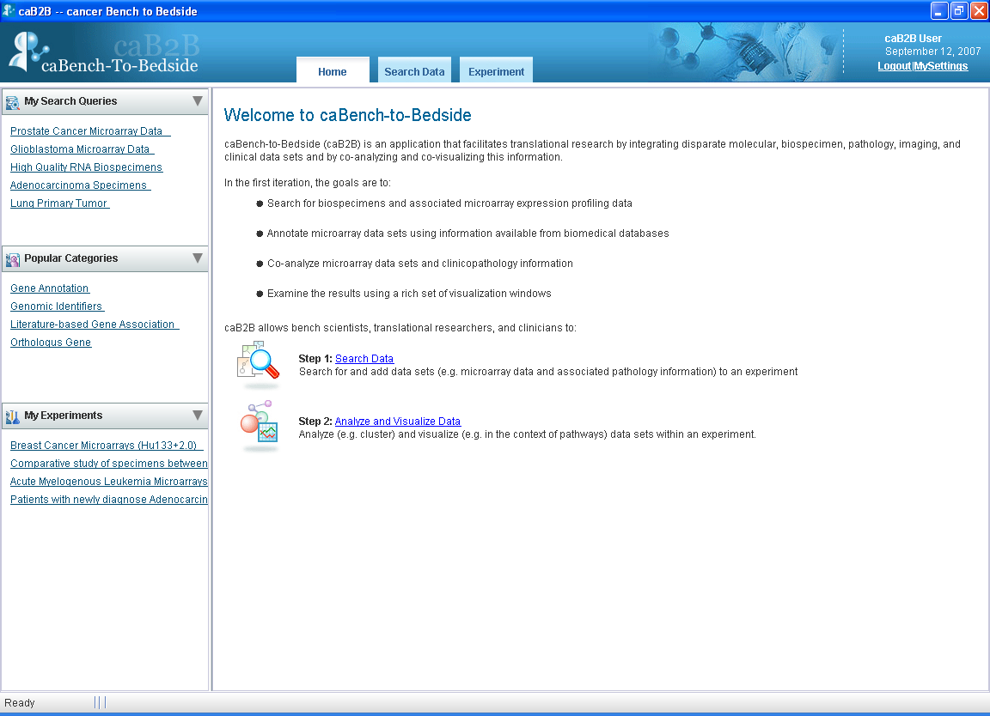
Figure 1.3. caB2B Homepage

Links on Home Page
Client Application’s home page provides a quick access to various features available in caB2B. It contains a link to the following features:
- My Search Queries – It gives quick access to all of your saved queries. From the homepage link, you can execute or modify the existing saved query. Only you can see queries created by you. Queries created by other users will not be visible to you.
- Popular Categories – It shows the five most popular categories. Popular categories are the categories that have been queried maximum number of times by the users.
- My Experiments – This panel shows you five most recently created experiments. Only you can see experiments created by you. Experiments created by other users will not be visible to you. You can click on these links to navigate to the experiment.
- Search Data – This link opens the query wizard. You can execute queries and create experiments using this wizard.
- Analyze and Visualize data – This link helps you in analyzing and visualizing the data.
- My Settings – You can override administrator-defined services to define the service instances that you wish to query.
- Logout – Using this you can log out of Client Application
As mentioned in the Conducting Research using caB2B section, you typically perform the following steps:
- Execute queries to obtain the dataset(s) of interest. The “Searching Data” chapter provides the details for this step.
- Analyze and visualize the data. The “Experiments” chapter provides the details for this step.

Popular Categories
Popular categories are the categories/classes that are queried the maximum number of times by a user. You can click on any of the categories shown under this and application will navigate to Add Limit page.
The popularity for a class increases when a user queries that particular class. When user queries administrator-defined category then the popularity of the classes, composing that category increases along with the category. For example, if a user queries for a class gene then its popularity would increase by one. Similarly, for administrator-defined category like genomic identifiers consisting of gene, messenger RNA and protein, the popularity of the category genomic identifier and individual classes will increase by one.

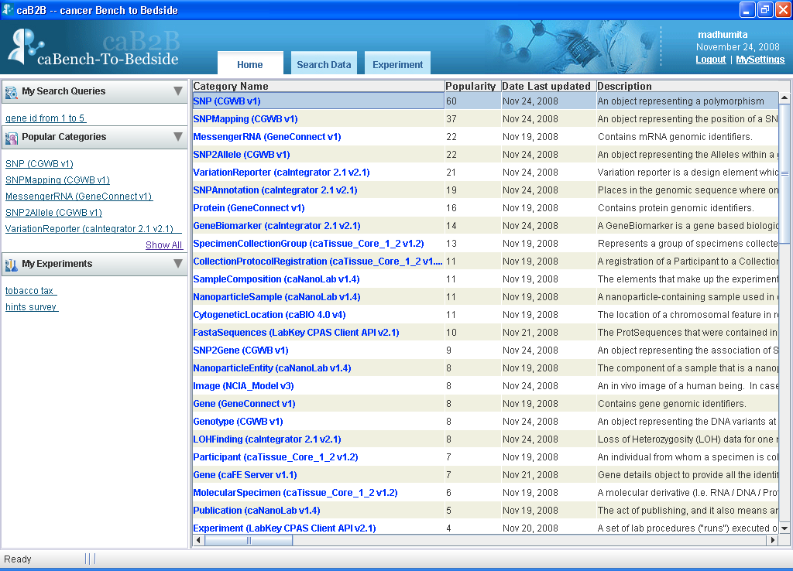

Figure 1.4. Popular categories

Overriding Administrator-defined Services
Administrator initially configures services for applications. These services are available for query in the Client Application. If you want to query services other than the ones configured by administrator, you can do so using My Settings link available in the Client Application. Overriding administrator defined services mean you can change the services defined by the administrator to query services of your interest.
Follow the steps given below to override administrator defined services:

- Click on My Settings link on the home page.
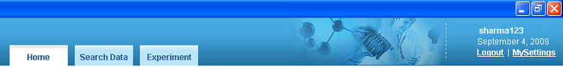

Figure 1.5. My Settings

- The My Settings window displays the various models that have been loaded into the application.
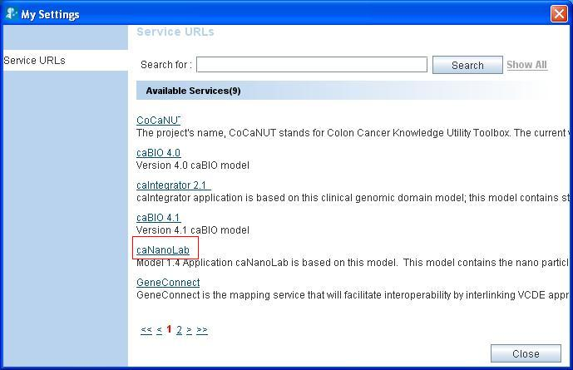
Figure 1.6. My Settings Page
- Click on a particular model name to display the list of services, example caNanoLab.
- Select/Deselect the services to override the administrator-defined services.

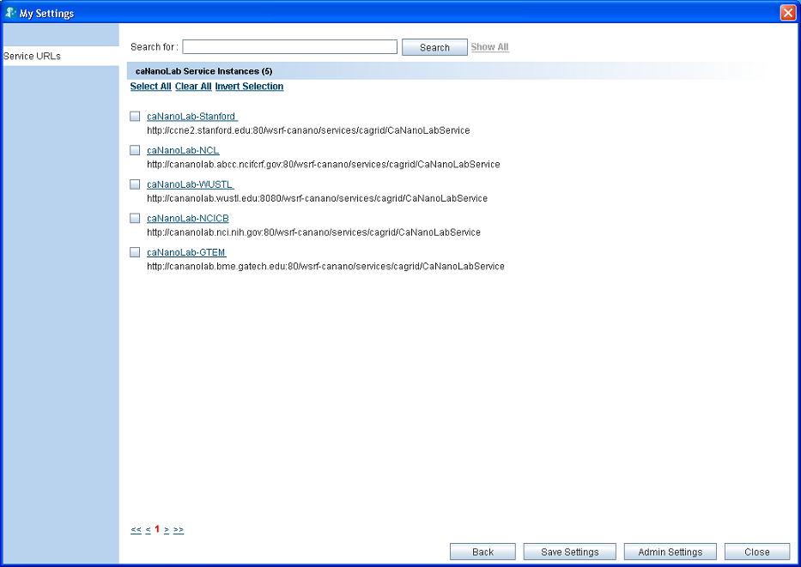
Figure 1.7. Service instances for the selected model
- Click Save settings.
- To restore administrator defined services click Admin Settings.

You might want to retrieve data from a specific instance for a particular query, but not want to apply these settings for all the queries. In such a case, configuring the services during the query is helpful (refer to Configuring Services for a Query).

Understanding Categories and Limits

What is a Category?
A category is a collection of searchable attributes from different classes of an application/model. A user can use a category to search, view, and add data to experiments. Administrator defines a category by collecting all the useful searchable attributes from different classes into a single category.
For example, administrator can combine attributes from Participant and Specimen classes of caTissuecore application to make a single category. You can use this category, which will have attributes from both the classes.
As the category and the class are a collection of searchable attributes, the terms are often used interchangeably in this guide.
The Gene Annotation category consists of the following attributes:
- Entrez Gene ID
- Gene Symbol
- Gene Name
- GenBank Accession Number
- Taxonomy ID
- Chromosome

Why do we need categories?
Categories help you to locate all the data elements needed for your search. It helps by combining the attributes from multiple classes.
Your administrator can create new categories based on your requirements. If there are queries that you perform regularly, discuss them with your administrator.

What is a Multi-model Category (MMC)?
caGrid offers multiple applications to store particular kind of data. You should be able to query the data irrespective of the application used to store it. Multi model category is a solution to address this need. Multi model category is single representation of data that is stored in different applications.
For example, biospecimen data can be stored in different tissue banking repositories like, caTissue Suite or caTissue Core.
Multi-model categories provide you a way to query across such multiple applications Multi-model categories consist of classes from multiple models; these may be different versions of same application or different applications. The attributes from different models having the similar data correspond to a single attribute in the multi-model category.
Your administrator will create a multi-model category that contains relevant data elements mapped to each other from respective models.
If you want to use a category, which combines multiple applications then, please contact your administrator to define the multi-model categories.

WARNING! | Only the Web Application supports the execution of the multi-model categories. You cannot execute a multi-model category query in the Client Application.

What is a Limit?
A limit is a condition (or criterion or predicate or condition) on a category. It is the smallest unit of a query. For example, female participants

What is a Query?
The collection of limits is a query. For example, female participants who have DNA specimens collected from their breast. This query has two limits: female participants, DNA specimens from breast. There are two categories involved in this query: Participant and Specimen.

Searching Data
This chapter describes how you can use Client Application to fetch data from available caGrid data services like caArray, GeneConnect, caFE, caTissue etc.
The chapter is broadly divided into the following subtopics:
- Search data – The Query Wizard
- Choose Search Category
- Define Limit(s)
- Define Search Results View
- Save Query
- Save Query
- Viewing and Saving Data List

Search data – The Query Wizard
This section explains steps required to obtain data. Click the Search Data tab on the Home page to display the Search data for Experiment wizard. The wizard begins at the Choose Search Category tab. (See Figure 2.8. Begin search for data ).
The wizard guides you through the following steps
Step one | Step two | Step three | Step four | Step five
Choose Search Category | Add Limits | Choose an Output Category  (Save Query) | View Search Results  (Save Query) | View Data List

To search data:
- Choose Search Category: Search for Category to apply limits.
- Add Limits: Add limits on the selected Category
- Choose Output Category (Optional): Select the output format (that is, define the results view). User can also save the query in this step
- View Search Results: View the results view in a Google-like search results page and add data to the data list (or shopping cart). User can also save the query in this step
- View Data List: View the data that you have added in the data list and create an Experiment.

Choose Search Category
This step helps you to search the category on which you want to define limits. For example, if you have a query with limits on participants, you can use this feature to find the Participant category.
To find the categories, do the following:
- Type the search string in the text box (near the top of the screen). Gene, gender, participant, RNA, experiment are examples of search strings.
- Click Search or press Enter.
- Search results display the categories that match the entered string as hyperlinks along with a short description. The application to which the category belongs is included in the search result.
- Once you find a category of your choice, click the desired search result to proceed to the next step.
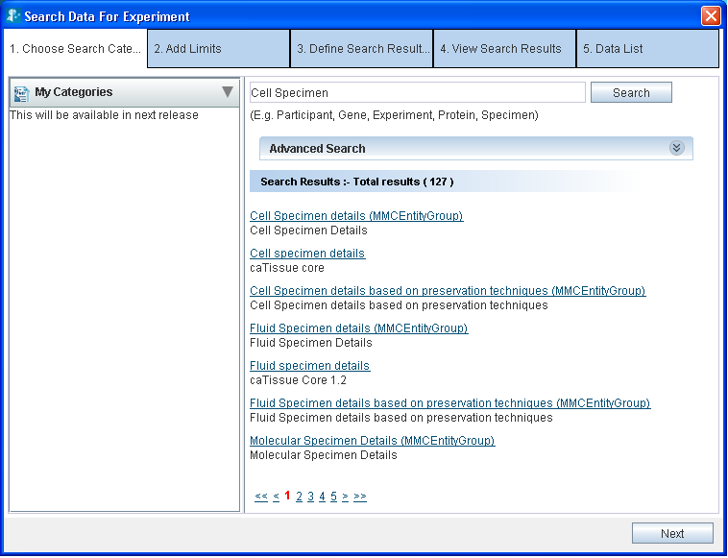
Figure 2.8. Begin search for data
Multi-model categories have MMC EntityGroup as the application name. In the Client Application, you cannot execute query using the categories that belongs to MMC EntityGroup.

More on searching:
- The search performed is partial and is not case-sensitive. Hence, the search for terms such as participant, PART or PARTICIPANT returns the same results.
- If a category description is long, you can view the complete description as a tool-tip by positioning the mouse over that description.
- If the number of matching categories is large, the system displays the results in multiple pages. Click the page numbers at the bottom to navigate through different pages.
- You can separate the multiple search terms by spaces or tabs. The system searches for each term individually and displays a collective set of matching categories. For example, if you enter the search string Participant Gene, the result would contain categories that match either Participant, Gene, or both.

Advanced Search
If your search returns too many results, you may use the Advanced Search. Expanding the Advanced Search box displays the advanced options that you can use to refine your search.
The Figure 2.9 depicts the default selection of the various options
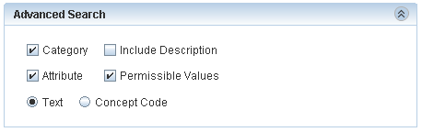
Figure 2.9. Advanced Search
Table 2.1 Advanced Search Options (Checkboxes and radio buttons)

Option | Description
Check Boxes
Category | Includes the category names in the search
Attribute | A category contains many attributes. Select this check box to include the individual attribute names in the search.  For example, Select attribute and search for gender. You will find the category Participant since it contains an attribute by name Gender.
Permissible value | Some attributes can have fixed set of values. For example, Gender can be Male, Female or Unspecified. Organ can be heart, lung, breast, and so on.  Permissible Values is a set of all such values.  Select this check box to include the permissible values in the search. For example, if you select the permissible value as Male the system displays the Participant category since it contains an attribute Gender that contains a permissible value Male gender.
Include Description | Includes the description text in the search  Note: Include Description check-box is enabled only for a text based search when you select the Category check box, the Attribute check box, or both.
Option Buttons
Text | The system matches the search string that you type with the name of the category, its attributes, or the permissible values based on the text. This is simple, most commonly used and the default way of searching..
Concept Code | The system treats the search string as an Enterprise Vocabulary Services (EVS) concept code and matches it with the concept code of the category, its attributes, or the permissible values thereby showing the matching categories. More details on the concept code can be found at http://bioportal.nci.nih.gov

You can make additional refinements with these options as illustrated in the Appendix A: Examples of category search

Define Limit
A limit is a condition (or criterion or predicate) on a category and multiple limits together form a query. Table 2.2 outlines two example queries and the limits added to them.
Table 2.2. Examples of Limit
Example | Category | Limit
Get the details about all the African male participants | Participant | Gender equals Male  Race equals African
Biospecimens from prostate adenocarcinoma | Specimen Characteristics | Tissue Site equals prostate
Biospecimens from prostate adenocarcinoma | Specimen Collection Group | Clinical diagnosis equals adenocarcinoma

Screen for define limit is shown below. It has three parts,
- Category search is present on the left hand part. It is explained in section choose search category
- Define Limit present at right hand side top is explained in section Steps for defining a limit
- Limit set present at right hand-side bottom is explained in section Limit Set – Diagrammatic View

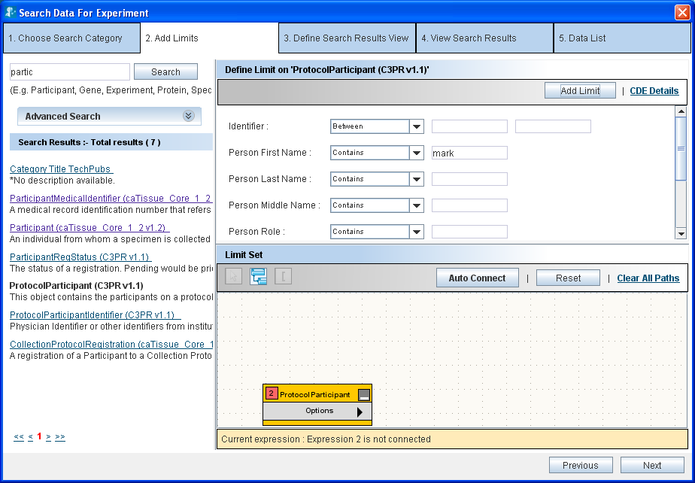
Figure 2.10. Define Limit

Steps for defining a limit
Perform the steps below to define a limit:
- Choose an operator from the list of operators adjacent to the attribute you wish to constrain.
- Specify the constraining values.
For a detailed explanation of the various operators and their values, refer to Appendix B: Define Limit: Operators and Values.

Example:
Single constraint – Show all male participants
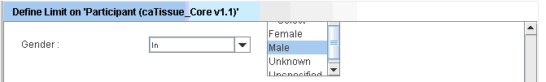
Figure 2.11. Male participants
Example:
Multiple constraints within one limit: Show all male participants who are alive. A user can define multiple conditions on an attribute by pressing Ctrl key while selecting different options: Show all specimens, which are either Serum or Plasma.

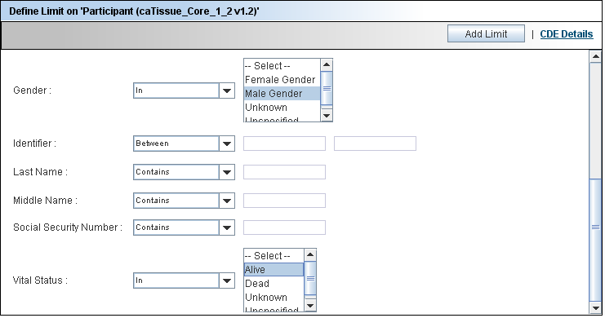
Figure 2.12. Male participants who are alive
WARNING! | Ensure that you click Add Limit at the top of the Define Limits screen before proceeding. In case you do not click Add Limit, the constraints that you have specified are not saved.

Limit Set – Diagrammatic View
Once the limits have been set on the category, clicking on the Add Limit button adds the category in the form of a yellow rectangle (also called a node) into the Limit Set panel. The Limit Set panel consists of the DiAGrammatic view (DAG view) panel. DAG view is like a canvas where all the categories on which limits appear in the form of nodes (Figure 2.13). On addition of a new limit, the system adds a yellow rectangle to the DAG that represents the limit. As you continue to add limits, the system adds corresponding rectangles to the DAG view.
These rectangles in the DAG view provide a graphical view of all the limits present in the query.
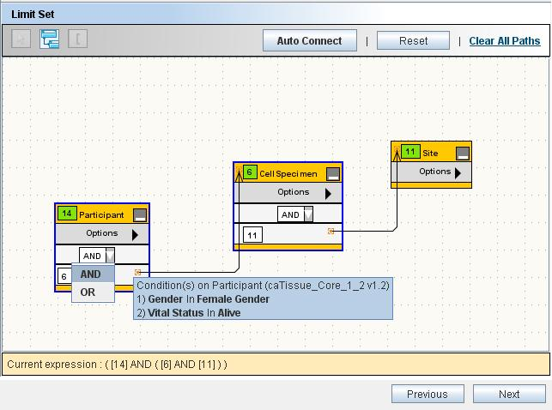
Figure 2.13. Limit Set Panel

DAG Operations
You can perform the following operations within the DAG view.
Table 2.3
View details of the limit |  | Position your mouse over a node to view the details of that limit.  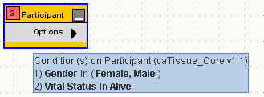
Edit the limit | Click Edit Limits from the Options menu of the node whose limits you wish to edit. Alternatively, double click the title of the node.  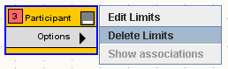  This opens the limit in the Define Limit panel in edit mode. Edit the constraints in the Define Limit panel, and click Edit Limit.
Delete the limit | Select the nodes that you wish to delete and press Delete.  Alternatively, you can delete a single node by selecting Delete Limits from the Options menu of the node as shown above.

Connecting the Limits
You must connect all the limits before proceeding to the next step.
When you specify multiple limits, you need to connect these limits to form an expression. Two limits may be connected by using either the AND or the OR operator. Following is an example of how the DAG looks when the limits are connected.

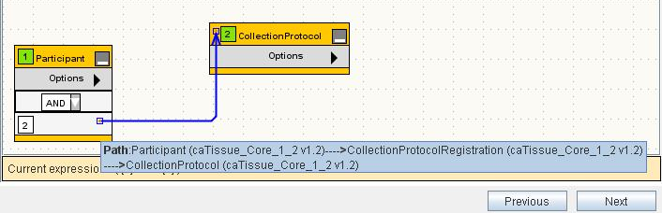
Figure 2.14 Connected Nodes
To connect the limits, you need to specify the following:
- The path to be taken in connecting the nodes
- The logical operator (AND, OR) in the dropdown box in a node
The rest of this section focuses on various ways in which you can specify the path(s)

What is a Path?
A path tells the system how two categories are to be connected. A path is a way to travel from one category to another. There could be multiple ways to connect two categories and the results of the query differ based on the path chosen.
For example, consider the two categories Specimen and Site (from the caTissue Core application). A Specimen is associated with the Site category in two ways: 1) Site where the specimen was collected 2) Site where the specimen is stored.
That means there are two paths between Specimen and Site: 1) Through Specimen Collection Group for the collection site.2) Through Storage Container for the storage site.
Query example 1: Show all the available specimens collected in Barnes Jewish Hospital. In this query, as you are specifically interested in a particular collection site, you should choose the path through Specimen Collection Group.
Query example 2: Show all the available specimens stored in Barnes Jewish Hospital. In this query, as you are specifically interested in a particular storage site, you must choose the path through Storage Container.
Therefore, it is important to choose the right path for your query.

Connecting Limits
Click Auto Connect. The system automatically connects all the boxes based on the settings provided by your administrator.
However, the administrator might not have configured the path between all the categories. In such cases, you can manually connect the limits as described below.
Example query: For all the male participants, show all the available specimens collected in Barnes Jewish Hospital.
- After adding three limits on the Participant, Specimen and Site the DAG view looks as shown in the figure below:
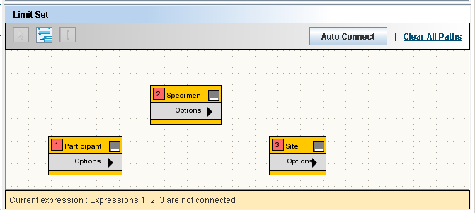
Figure 2.15. Limit Set
- Click the Participant and the Specimen rectangles to select them.
- Click Connect Limits to connect the two nodes. The resulting DAG view looks like Figure 2.16.
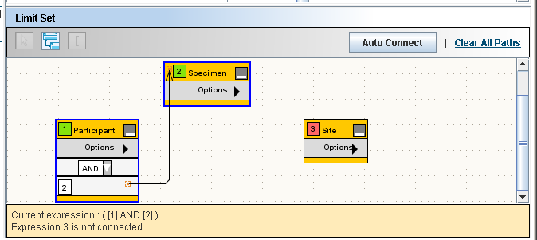
Figure 2.16. Limit Set with Two Connected Limits
Note: If there is only one path between Participant and Specimen, the system will automatically connect it. Default operator is AND, it can be changed to OR using operator dropdown.
- Select the Specimen and Site rectangles and click Connect Limits.
- Since there are more than one path between Specimen and Site, the system cannot connect the limits on its own. Therefore, it displays the Ambiguity Resolver window as shown in Figure 2.17. Path Ambiguity Resolver
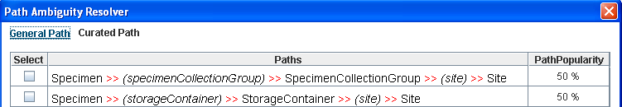
Figure 2.17. Path Ambiguity Resolver
- Select the first path to find out the collection site.
- Once the path(s) is determined, the system creates a connection between the two nodes (see figure below). You can position the mouse over the connection to view the path(s) that you chose.
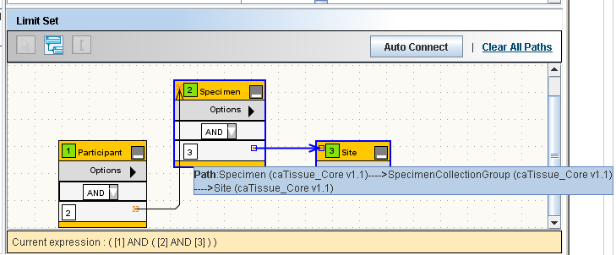
Figure 2.18. Limit Set with Three Connected Limits
- Specify the operator (AND or OR) using the dropdown box in the node. For above query the operator will be AND
- Click Next.

Deleting a Connection
You can delete a connection by clicking the connection arrow between the two nodes and pressing the Delete key.

The Information Panel
The Information panel is located at the bottom of the Limit Set panel.
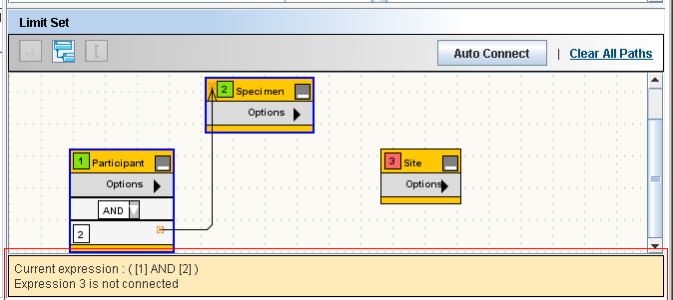
Figure 2.19. The Information Panel
The Information panel provides the following information:
- The expression formed because of how the limits are connected.
- Limits that are not yet connected to any other limit
- To execute the query, there should not be any unconnected rectangles.

Reset, Previous and Next Buttons
These buttons are located on the Limit Set panel (refer to, Figure 2.13. Limit Set Panel)
- The Reset button clears all the specified limits.
- The Previous button takes you to Choose Search Category step of the wizard.
- The Next button takes you to the Choose Output Category step of the wizard. A valid query allows you to proceed to the next step. System displays an appropriate error message if the query is invalid.

Define Search Results View
After specifying the limits, you proceed to choose the output category for the data. For example, “show all the participants who had biospecimens collected from their breast”. Participant is the category that you want to view, based on a limit on the specimens.
The Define Search Results View tab allows you to select the output category for the query. 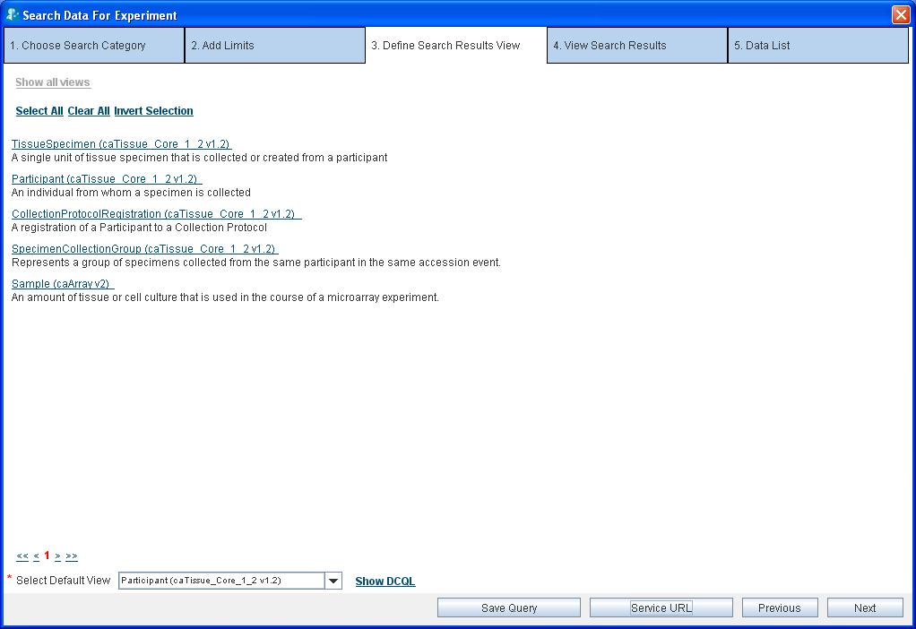
Choose the Default view here
Figure 2.20. Define Search Result View.
As shown in Figure 2.20, the Select Default View dropdown box at the bottom of the screen shows all the categories present in the query. From the Select Default View dropdown box, select the category whose data you wish to obtain.

The Next, Previous, Save Query and Service URL Buttons
- To edit the limits, click Previous and go to the Define Limit step
- Click Next to execute the query that you have created
- Click Save Query (refer to Save Query) to save the query.
- Click Service URL to modify the services.

WARNING! | On clicking the Next button, the system executes the query and fetches the data from appropriate data services over the caGrid.  This step could be time-consuming. It may take few minutes to couple of hours based on the network speed and complexity of the query.

Configuring Services for a Query
A query fetches data from all the services configured by you using My Settings. If you have not selected the services, then services selected by the administrator will be queried. For a particular query, you might want to get information from specific instances and for some other query; you might need some different instance. For such cases, Client Application allows you to modify the services for a particular query just before executing it.

To select the services while executing a query follow the steps given below:

- Click Service URL button on the Define Search Results View page.

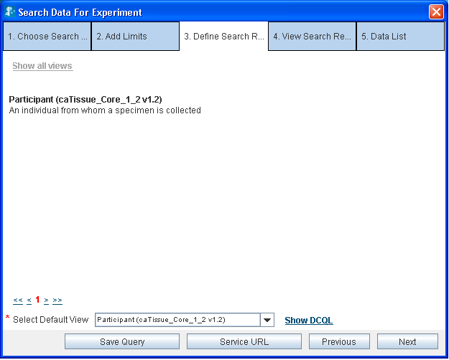
Figure 2.21. Service URL button on the query page.

- Click the model name.
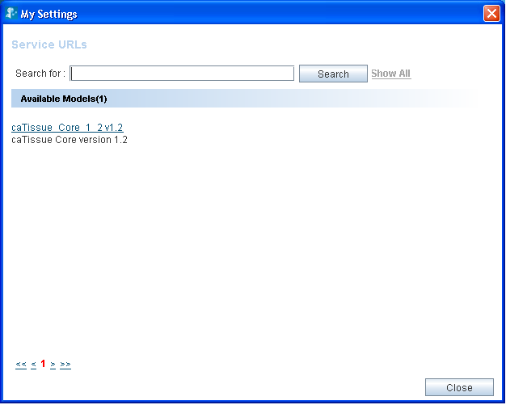
Figure 2.22. Showing all the models available in the query
- Select the services.

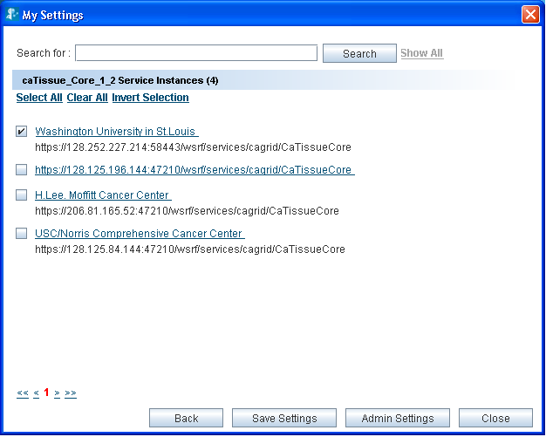
Figure 2.23. Service URL selection
- Click Save.

If your query involves categories from more than one model, then you can set the services for all the models involved in your query.

The services defined at this step are applicable to this query only. This does not modify the services you configured using My Settings. These settings are not applicable for the next query.

DCQL Viewer
DCQL is the query language used by caGrid data services to express queries against a data source using an object-oriented language. It is the query language used by the caGrid to retrieve data from various data services. It is in the form of XML schemas. A user who is new to caGrid can view the DCQL and learn it to use the language.
To view the DCQL on the Define Search Results view tab click on the Show DCQL link. The pop-up window shows the DCQL executed for the query.
You can click Export to download the DCQL query in the XML or TXT format.

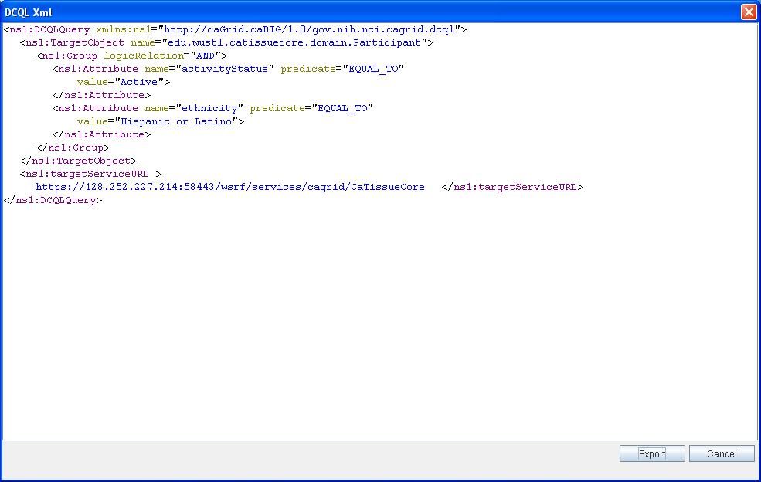
Figure 2.24 DCQL query

Save Query
This option helps you to save the query created using the DAG. While saving a query all the classes present in the query get saved along with the conditions defined on them.

Why to Save Query?
A saved query helps you to view the result of the query without having to create the query in DAG. You can create the query in DAG once and save it for later use. You can parameterize a saved query by saving conditions on the attributes present in the query (described further below). You can execute a saved query with or without changing the conditions defined in the saved query.

Advantages of Saving a Query:
- Saving complex queries with multiple nodes
- You can execute the saved queries later to get the results. Saved queries created by one user will not be available to another user.
- Setting up parameterized queries that allow you to use the same query for a variety of conditions on a single attribute
- Administrator for the Web Application can save query as a keyword query or saved search for Web Application users.

Types of Saved Queries:
There are two types of saved queries available in the Client Application:
- Non-parameterized queries: These queries do not have any parameters defined. It means that you cannot modify these queries at the time of execution.
- Parameterized queries: These queries have parameters defined while saving it. You can modify the parameters at the time of query execution to generate a new query.

Parameterized queries for caB2B Web Application user:
The queries saved through Client Application are available in the Web Application. There are two types of queries available in the Web Application:
- Saved Search: A saved search is a normal parameterized query saved in the Client Application. You can execute it by defining conditions on the available parameters. Application saves the queries along with the operators you selected. Hence, if you defined AND operator between a pair classes and an OR operator between another pair, the query will have the AND and OR operator between that set of classes. The Saved search section displays all the available parameterized queries.
- Keyword Search: A keyword search is a parameterized query with OR operator defined between the attributes and the classes irrespective of the operator defined by you. In addition, a keyword query saves only the string attributes from the list of user-defined parameters.
The Saved search section of the Web Application displays the available parameterized query created by an administrator. The keyword queries are not visible in Web Application. They are executed when you enter a keyword in web application (refer to End User Manual of Web Application)

How to Save Query?
To save a query, add limits on categories and connect them via the available paths. After forming the query navigate to the Define Search Results View tab, which provides you the option to save a query. Use the Save Query option at the bottom of this tab to save the query. The Save Query option is also available on the View Search Results tab.

How to save a non-parameterized query?
- Click Save Query (as shown in Figure 2.20. Define Search Result View.).
- Enter the Title and Description for the query to be saved, in the save query panel (see the figure below).
- Select the Keyword search, Saved search or Both option based on the type of query to be saved.
- Click Save.
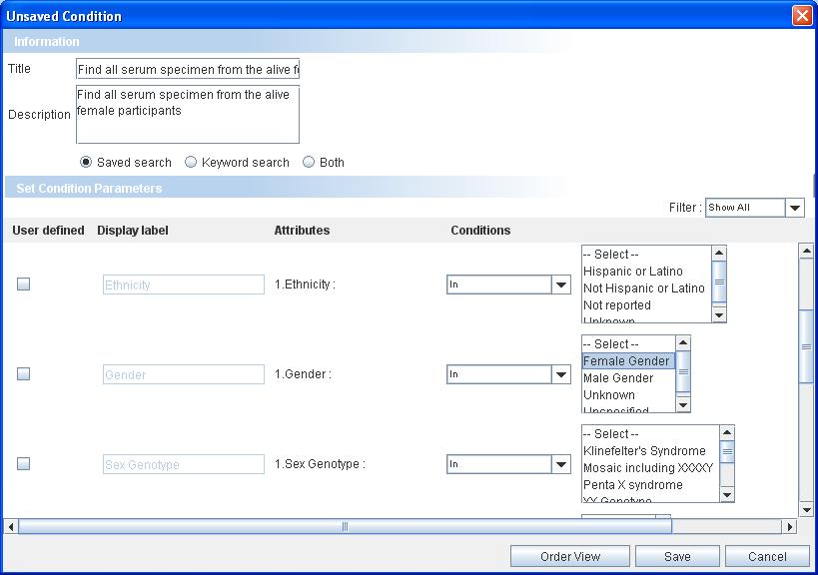
Title
Description
Figure 2.25. Save Query Panel-Non Parameterized Query

How to save a parameterized query?
- Click Save Query (as shown in Figure 2.20. Define Search Result View.).
- Enter the Title and Description for the query to be saved, in the save query panel (see the figure below).
- Select the Keyword search, Saved search or Both option based on the type of query to be saved.
- Select the User Defined Check Box for the attribute you wish to save as a parameter.
- Use Filter option to define condition on any of the attribute of the category. It includes attributes other than those initially defined in the query.
- Click Save.
Click Cancel to exit without saving the query.
If you are the Administrator of the Web Application, your saved query would be visible in the Saved Search panel of Web Application.

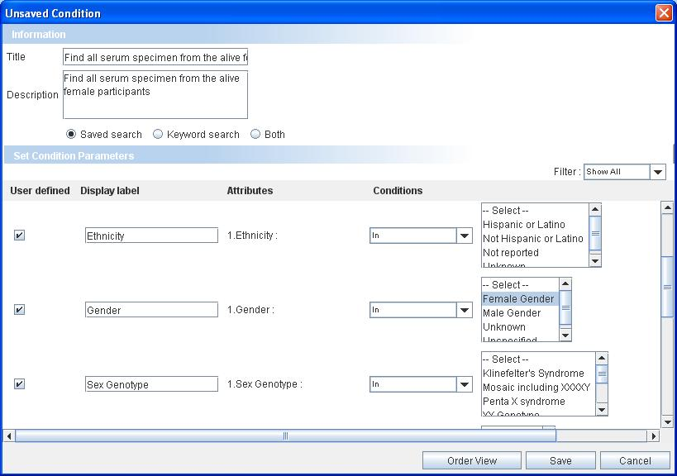
Title
Description
Figure 2.26. Save Query Panel-Parameterized Query
The Saved queried with a # in the query title are keyword queries. You can see these queries in the Client Application.

Executing a Saved Query
All the saved queries are visible in the My Search Queries stack box in the left hand side panel on the home page. To execute a saved query, follow the steps given below:
- Click on the title of the query to be executed
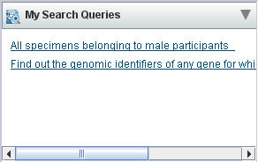
Figure 2.27. Saved Query Stack box
The Saved Query Panel opens.
- For non-parameterized queries, click Show Results on the execute query panel
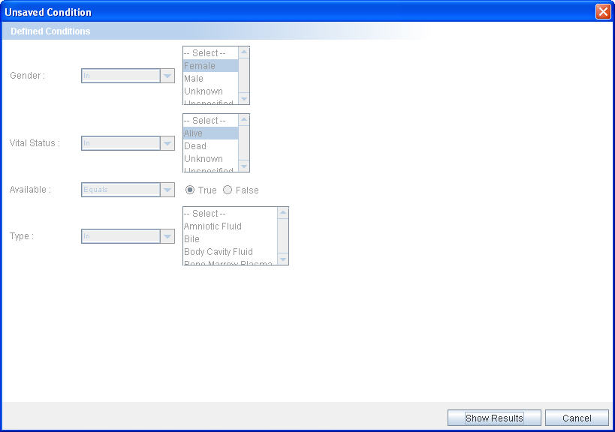
Click to execute

Figure 2.28. Execute Query Panel- Non Parameterized Query
- For parameterized queries,
- Change the conditions for the parameterized attributes
- Click Show Results.
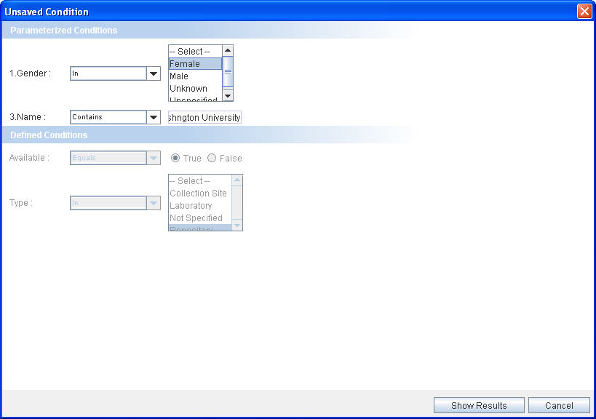
Click to execute

Figure 2.29. Execute Query Panel-Parameterized Query

The save query option provides an easy alternative way of executing the queries without actually forming the query again. The parameterized query allows changing the conditions on attributes thereby allowing flexibility to the saved queries.
Use the Web Application to execute the saved keyword queries (refer to caB2B Web Application User Manual).

View Search Results
The View Search Results tab displays the results obtained by executing the query defined in the previous steps. The concept of viewing results in caB2B is similar to viewing results after a Google search. The following are the similarities:
- Client Application returns a set of records that match your limits.
- You can see some details of the record along with the record.
- Click on one of the records to view more details.
- Records provide additional information, for example, from Participants you can see the Collection Protocol in which they are registered. This is similar to Google where, after you click one of the hyperlinks, you can traverse into other web pages by clicking the hyperlinks within that page.
- As in Google, you will see the results divided into multiple pages for easy navigation.
If you find any data of interest, you can add it to the Data List.
The following image displays a typical results view. The View Search Results tab displays the records that match the limits and the data that you have already added to the data list.
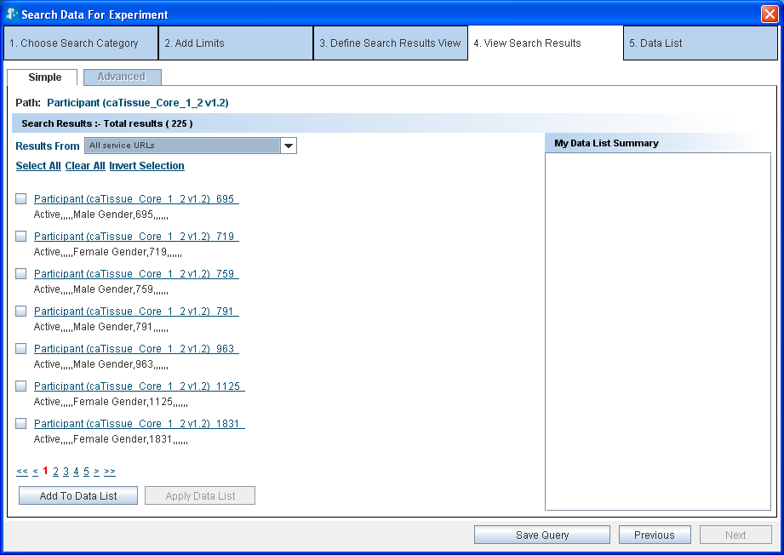
Figure 2.30. View Search Results
You cannot execute a query on a multi-model category in the Client Application. Application shows you a message stating that:
Currently there is no support for Multimodel category query execution in caB2B client .Please use Web Application for executing Multimodel category query

Record Details
Click on the hyperlink of a record on the View Search Results to take you to the Record Details page. Here you can view the values of all the attributes of the category.
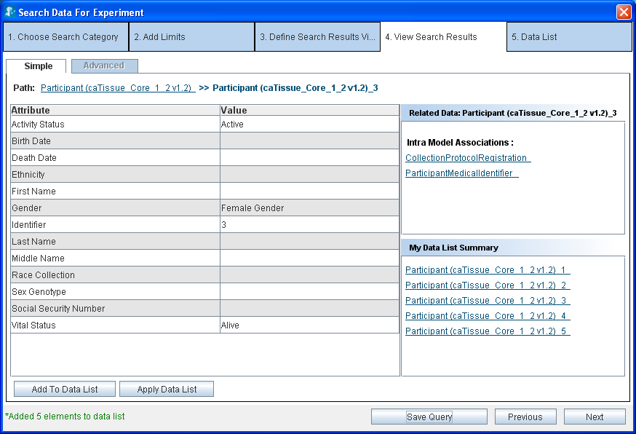
Figure 2.31. Results’ Details
Figure 2.21 shows a view of the Results Details page it shows the following sections:
- Value of all the attributes in the record
- Links to related data
- Summary of the records that you have already added to the data list

Related Data
As shown in Figure 2.31. Results’ Details above, the Related Data box on the right displays the categories related to the current category. Click on any of the categories to display records for that category. For example, if you are currently viewing records of Participant (caTissue), the related data box shows the following categories:
- Collection Protocol Registration (caTissue)
- Participant Medical Identifier(caTissue)
If you now click Collection Protocol Registration, you would see the Collection Protocol Registrations related to the Participant you are currently viewing.

Breadcrumbs
Breadcrumbs or a breadcrumb trail is a navigation technique used in user interfaces. Its purpose is to give users a way to keep track of their location within programs or documents. (Definition from Wikipedia entry)
As you traverse the results view, the top of the page displays the breadcrumbs. For example, if you were viewing a molecular specimen record related to a participant, you would see the path as
Participant >> participant_1125 >> collection protocol registration >> specimen collection group >> molecular specimen
This means that you originally queried for participant. Then you fetched related molecular specimen for participant_1125 via collection protocol registration and specimen collection group.
Click any of the links in the breadcrumbs to navigate back to the corresponding page. For example, you can click Participant in the above path to go back to the page with the list of participants.

Adding data to the Data List
A data list is like a shopping cart, which enables you to add interesting data to the shopping cart as you traverse through the results. You can add data to the data list in two ways:
- Click Add to Data List
- Click Apply Data List
As you add the data to the data list, the My Data List Summary box on the right hand side reflects the updated data list.

Add to Data List
Select the record that you want to add to the data list and click Add to Data List. You can either add one record at a time or add multiple records by selecting the checkboxes placed along with the record summary.

Using Apply Data List
Once you obtain the related data for a particular record, Apply Data List allows you to fetch similar related data for several other records easily. We outline an example of this approach below.
A typical user query might do the following:
- Fetch the data for the Participant category.
- Fetch related data from the category Molecular Specimen for a record of Participant, for example, participant_1125.
- Add the Molecular Specimen record to the data list.
Figure below shows the resulting data list.
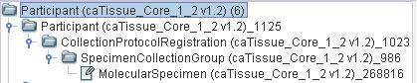
Figure 2.32. Data List
If you wish to obtain the Specimen data for other Participant records, you have to fetch related Specimen for one Participant record at a time. The Apply Data List functionality allows you to fetch the Specimen for several Participant records in a single operation. To do this, perform the following steps:
- Fetch the data for the Participant category.
- Fetch the related data from the category Specimen for a record of Participant, for example, participant_1125
- Add the Specimen record to the data list.
- From the View Results screen for the Participant records, (see Figure 2.30. View Search Results) select Participant records for which you want the related Specimen records.
- Click Apply Data List, it will fetch Specimen for all selected Participant records.
- The status bar displays a success message when the operation is complete. Click Next to see the data list. Figure 2.33 show the resulting data list.
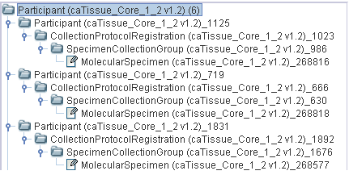
Figure 2.33. Result of Apply Data List to participants with id 1125, 719, 1831

How Apply Data List functionality works
To understand this functionality better, consider a slightly more complicated data list below:
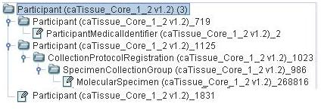
Figure 2.34. Data List
The data list has the following records:
- For participant_1125, related Collection Protocol Registration, Specimen Collection Group and Molecular Specimen records are present.
- For participant_719, related Participant Medical Identifier is present.
- For participant_1831, there is no other related data.
Now, Apply Data List to the participants with id 1125, 719, 1831. Figure 2.35. shows the resulting data list
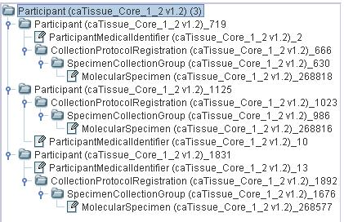
Figure 2.35. Apply Data List

As seen in Figure 2.35, application has fetched following related data:
- For participant _719, the system fetches Collection Protocol Registration, Specimen Collection Group, and Molecular Specimen (as participant_1125 had Collection Protocol Registration, Specimen Collection Group, and Molecular Specimen).
- For participant_1125, the system fetches Participant Medical Identifier, as these were the related data for participant_719.
- For participant_1831, the system fetches all of Participant Medical Identifier, Collection Protocol Registration, Specimen Collection Group, and Molecular Specimen.
As a result, each participant contains the related data for of Participant Medical Identifier, Collection Protocol Registration, Specimen Collection Group, and Molecular Specimen.
Thus, the Apply Data List operation results in a homogenous structure in the data list. The system fetches related data for all the other records such as the related data present for one record.

The Next, Previous and Save Query Buttons
- Click Next to view the contents of the data list. It will take you to Data List tab.
- Click Previous to go back to previous tab, which is Define Search Results View tab.
- Click Save Query to save the query (refer to Save Query above).

Group Results by Service URL
You can configure multiple services to fetch the results. Results are fetched from all the configured services. The View Results page shows all the results from the various services. You can view the results fetched from a particular service by filtering the results. To filter the results follow the steps below:
- Expand the Results From drop down in the View Search Results tab.
- It shows the number of results fetched from each service.
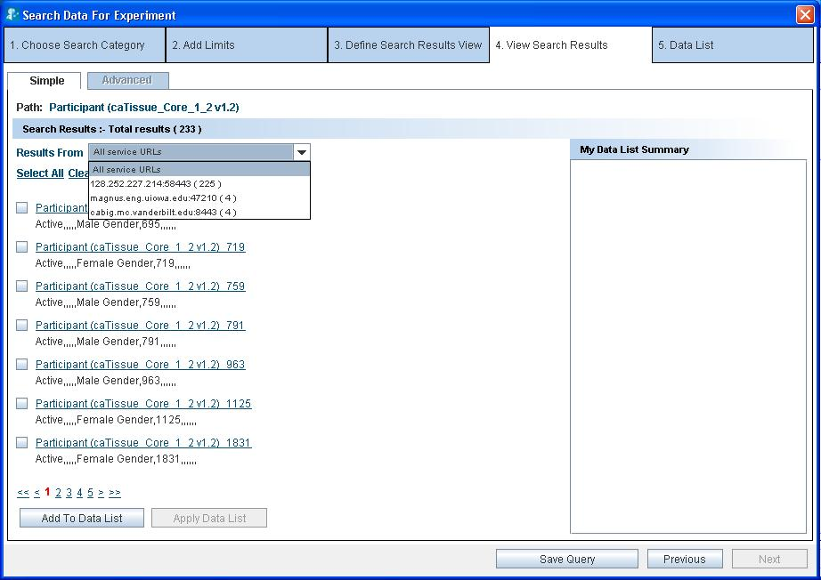
CaTissue service at Holden Comprehensive Cancer Center
Figure 2.36 Results grouped by service URL.
- Click on any one of the service in the drop down to see the results from that particular service.
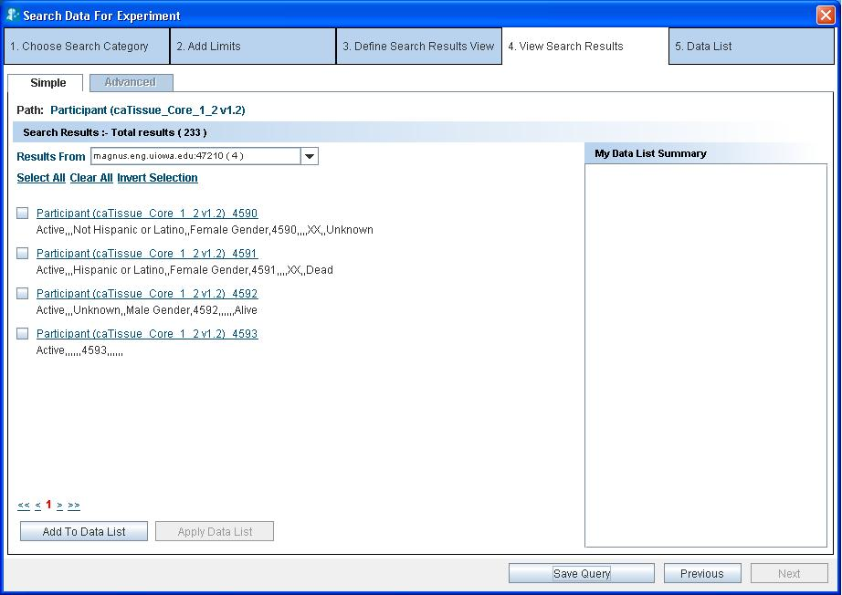
Results from selected service instance
Figure 2.37 Results from the selected service URL instance
You can then proceed with related data and saving the data list for the particular required service rather than all the services.

Viewing and Saving Data List
After adding the records of interest to the data list, you can get the consolidated view of the data list that shows all the records added to the list in a hierarchical tree fashion. These include all the records as well as the details of a particular record. You can also export the data list into a Comma Separated Value (CSV) file or create an Experiment by using the contents of the data list.
The following figure shows the data list tab:
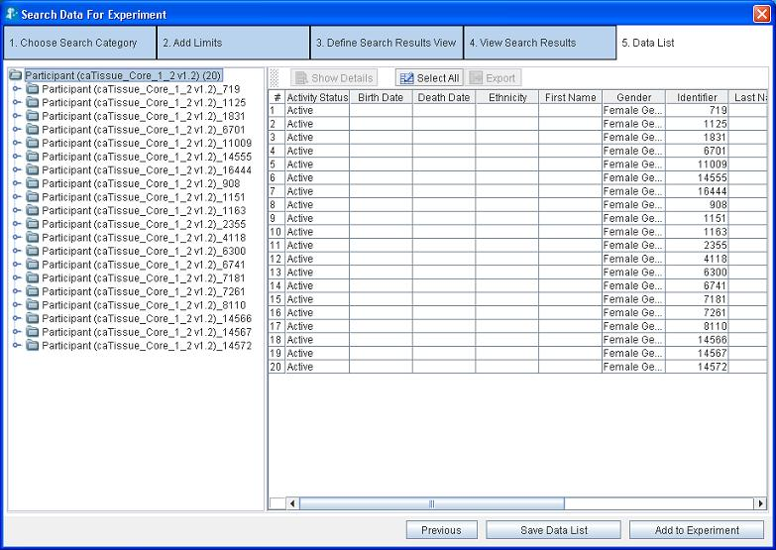
Figure 2.38. Data List

The left-hand side panel shows all the records that you have added to the data list in a tree format. Each node in the tree represents either a category or a record of a category.
- For a node representing a category:
- The number of records for that category is shown in parentheses. For example, Participant (20) means that you have added 20 records for the Participant category.
- Clicking on the node updates the right hand side panel to show a spreadsheet containing the records of that category (see figure above) with the columns depicting the attributes and the rows are depicting the records (refer to, Figure 2.38. Data List).
- For a node representing a record
- You see the unique identifier for that record. For example, Participant_719 represents the record with identifier 719.
- Clicking the node updates the right hand side panel to show the details of that record.
The right hand side panel shows the record details. The details shown in the panel depends on the record chosen in the left hand side panel.
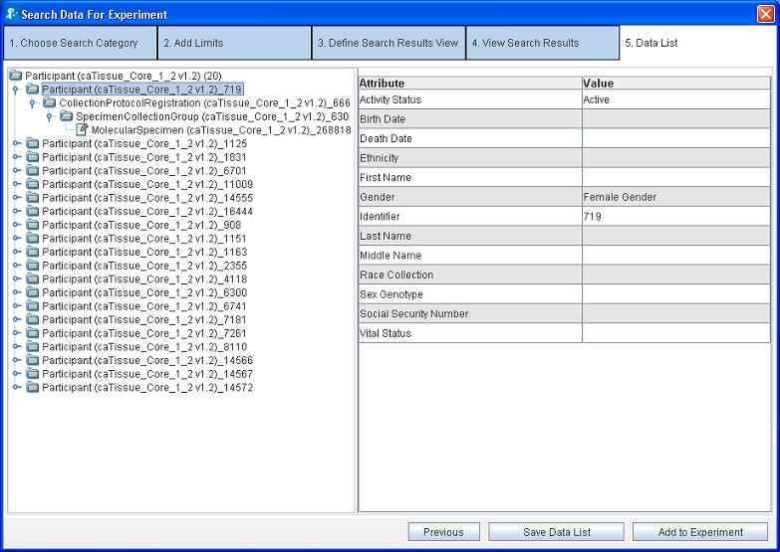
Figure 2.39. Record Details for a single record in Data List

Operations on the Data List
You can perform the following operations on the data list:
- Export the data list into a CSV file – Click Export. (see Figure 2.38. Data List)
- View details of a particular record – Click Show Details.
- Save the data list – Click Save Data List.
- Add the data list to an Experiment – Click Add to Experiment (see Chapter 3 for additional information).

To save the data list:
- Click Save Data List.
- Type the title and description for the data list.
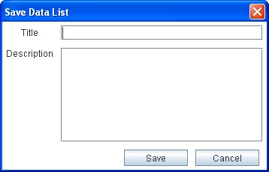
Figure 2.40. Save Data List Panel
- Click Save. When you save the data list, the system displays a success message in the status bar. Application saves the data list in the database.

Currently, Client Application does not support saving a data list with Date attribute.

Experiments
After you search and add some data of interest to the data list, you can create an experiment using that data. This chapter explains the various operations that you can perform on the data sets collected.
This chapter covers the following topics:
- What are Experiments and Projects?
- Creating an Experiment
- Viewing the Existing Experiments
- Working with an Experiment
- Filtering Data
- Visualizing Data

What are Experiments and Projects?
An experiment is a collection of data. You can perform the following operations after you create an experiment:
- Visualize data using various viewers such as bar charts and scattered plots.
- Create new data sets by applying filters on the existing datasets
A project is a collection of experiments. A project can contain many experiments or other sub-projects. The grouping of experiments into projects helps you to manage multiple experiments easily.
You can perform the following using caB2B
Step no. | Description | Related Section
1 | Search for data | Search data – The Query Wizard
2 | Create experiment with this data | Creating an Experiment
3 | Open the experiment you have created | Opening an Experiment
4 | Filter the data further if desired | Filtering Data
5 | Save the filtered data | How to save filtered data
6 | Plot data as a scattered plot | Visualizing Data

Creating an Experiment
To create an experiment, you need to have a saved data list with the required data. See Viewing and Saving Data List for more details.
After you have saved the data list, do the following to create an experiment:
- Click Add to Experiment (Figure 2.38. Data List). This opens the Create New Experiment window.
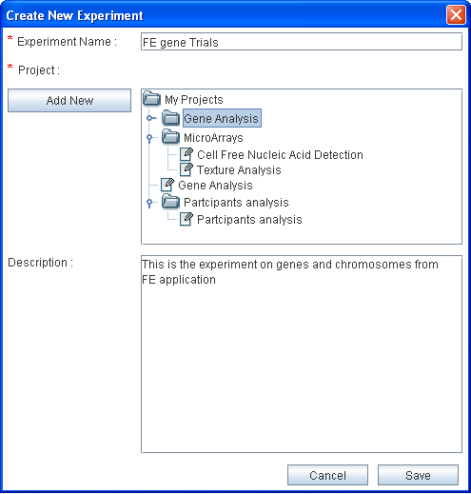
Figure 3.41. Create New Experiment
- Give an appropriate name to the experiment.
- Select the project in which you wish to create this experiment (see note below).
- Provide a description for the experiment.
- Click Save.

You can now close the Search Data wizard to return to the Home page and to open the experiment.
Similarly, you can search for gene, RNA, protein and save the experiment. Further, the features of experiment are explained by taking an example of gene and related intramodel associations.
- To create a new project, perform the following:
- Select the parent project under which you wish to create a new project
- Click Add New. This adds a new sub project under the selected project with the default name– New Project.
- To rename the new project
- Select the project.
- Press F2.
- Type the desired name.
- Press Enter.

Viewing the Existing Experiments

On the caB2B home page, click the Experiment tab. This opens the My Experiments page.
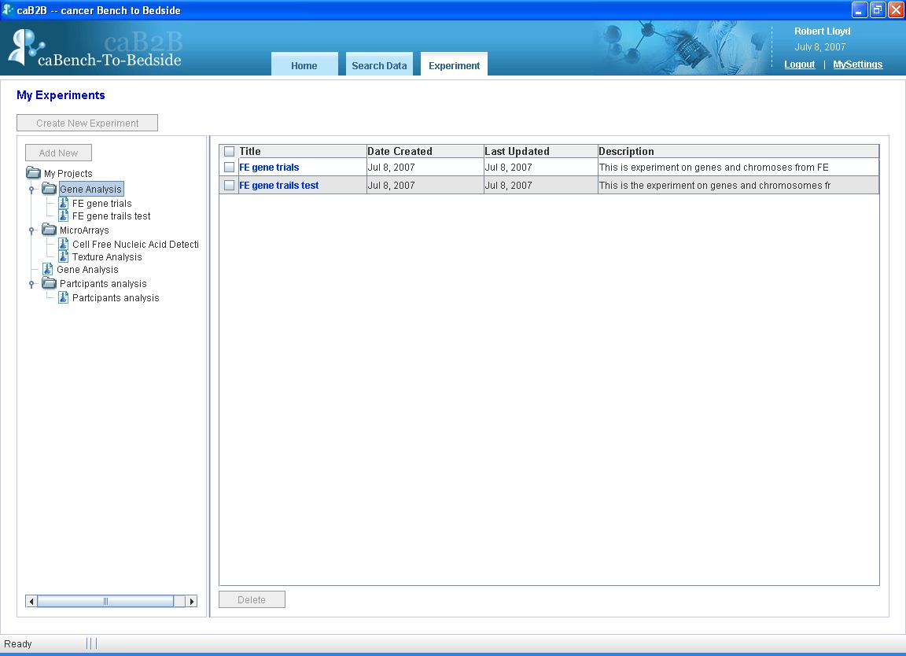
Figure 3.42. My Experiments
You can see all the projects and experiments that you created in the left panel.
When you select a project in the left hand side panel, the system displays a list of experiments in the project in right hand side panel.

Opening an Experiment
To open an experiment, go to the My Experiments page and click on the experiment title seen in the right panel (see Figure 3.42. My Experiments).
On opening an experiment, you see the Experiment Details page. The experiment details page shows the data categories added to experiment. It gives you an option to modify the experiment by adding a new column, adding new data, exporting data etc. All these options are also available on the right click menu.
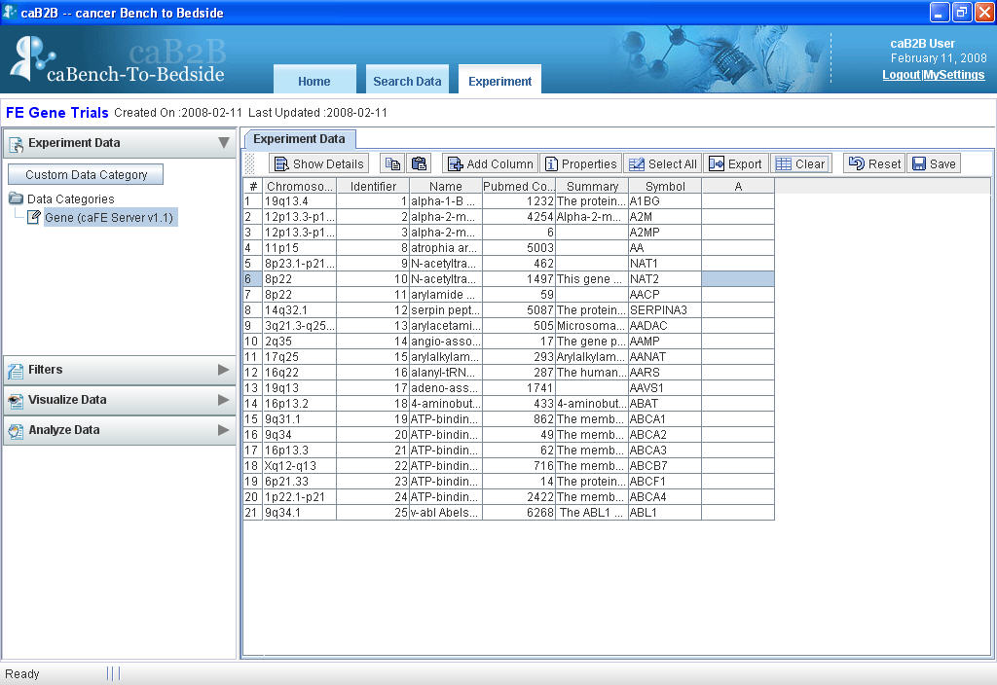
Figure 3.43. Experiment Details
The table below lists the various options provided by the spreadsheet on the experiment details page:
Button | Description
 | Shows details of the particular record
 | Copies data of the selected cells
 | Pastes the data to the specified cells
 | Adds a new column to the spreadsheet
 | Shows the properties of the spreadsheet, like which attributes are visible, what filter is applied
 | Selects all the records
 | Exports data to a CSV file
 | Clears the user added data from the selected cell
 | Undo’s all the changes and shows the original data
 | Creates a data category

Working with an Experiment
The Experiment Details page consists of the following sections:
- The Operations panel on the left hand side
- The Visualization panel on the right hand side

The Operations panel
The Operations panel encompasses the following collapsible boxes.
Table 3.3. Operations on the Experiment Page
UI Elements | Description
 | It displays a list of all the data categories present in the experiment. See How to save filtered data in this chapter for more information.
 | It shows all the filters that you applied to the data categories. If none, then it shows filters that you can apply to the data of the selected data-category. See Filtering Data in this chapter for more details.
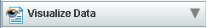 | It shows the visualization options available for the selected data-category. See Visualizing Data in this chapter for more details
 | Shows the analytical services that are applicable to the selected data-category

Visualization panel
This is the right hand side panel on the Experiment Details page (see Figure 3.43. Experiment Details). This panel can contain several pages at a time (see figure below). You can switch between the pages by clicking on the tabs at the top of this panel.
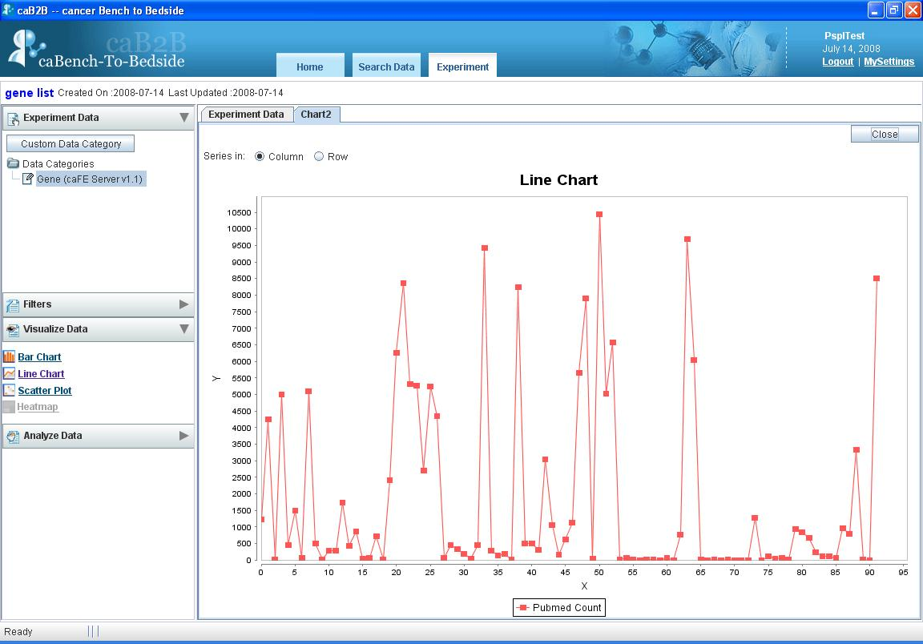
Figure 3.44. Visualization Panel
The visualization panel updates itself based on the operations you perform in the operations panel. For example,
Operations panel | What happens in Visualization pane
Click a data-category in the Select Data Categories box | The Experiment Data tab is updated to show the records of that data category
Choose a visualization from the Visualize Data panel | A new tab is created to display the desired visualization

Filtering Data
The purpose of creating experiments is to perform analysis on the data. To aid the analysis, caB2B provides features to filter the data so that you can zero in on the data of interest.
After filtering the data, you can save the filtered data as a Data Category. For example, if you have created an experiment with all female participants, you can now create different data categories based on age less than 50, age between 50 and 65 and age greater than 65.

How to filter data
- Select the column to be filtered, select the filter from the Filters stack box, (located in the left hand side panel)
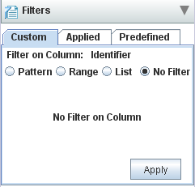
Figure 3.45. Filter Stack box
- System displays appropriate filter controls.
- Choose one of the available filters and specify the conditions that the data must satisfy (refer to, Appendix D: Types of Filters).
- Click Apply.
- The Experiment Data tab shows the filtered data.
- The filter that you have applied is also shown in the Applied tab of the filters stack box on the left hand side.
You can now save the filtered data as a new data-category (refer to How to save filtered data for more information) and use it to perform analyses or visualization.
You can filter on multiple columns by successively applying filters on those columns. For example, to obtain female participants between age 30 and 40
- Apply the filter “Gender = female”.
- Then apply the filter “age between 30 and 40”.
For the details of the available filter controls and their mechanism of action, see Appendix D: Types of Filters.

How to edit a filter
- Choose the column to edit the filter.
The Filter stack box shows an appropriate filter with the values that you had specified earlier.
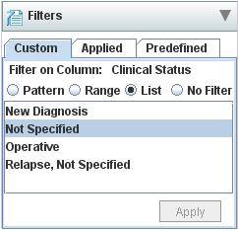
Figure 3.46. Edit Filter
- Specify new values for the filter (refer to, Appendix D: Types of Filters).
- The Experiment Data tab shows data based on the new filter.
- The filter criteria shown in the Applied tab of filters stack box in the operations panel is also updated.

How to remove a filter
- Choose the column whose filter you wish to remove.
- Select the No Filter option.
- Click Apply.
- The Experiment Data tab shows data after removing the filter.
- The filter is also removed from Applied tab in the filters stack box in the operations panel.

How to save filtered data
Once you apply filter to a data set, you can save the filtered data as a new data category. You can create as many data categories as you want. You can use these data categories for data analysis.
To save a filtered data category,
- Click Save (It is located in the toolbar of the right hand side panel of the experiment details page. Refer to Figure 3.43. Experiment Details)
- The Save as Data category panel appears.
- In the Title field, type the title of the new data-category.

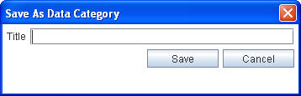
Figure 3.47. Save Data Category Panel
- Click Save.
The new data category will appear under Custom Data Categories section in Experiment Data box of the operations panel.

Custom Data Category
In an experiment, there are various data categories, like participant, specimen etc. An individual data category does not make much sense. Data in different data categories is related to each other. Thus, a user would like to combine data from different categories to generate a unified view for all the categories.
Custom Data Category (CDC) is a way to bring data from various categories under a single category. For example, you want to see the specimen details and participant information in a single view. For this, you can create a CDC with the desired attributes from the participant and the specimen class and create a new category.

How to create CDC
- Click Custom Data Category (located at the top of the Experiment Data box on the left hand side panel of the experiment page).
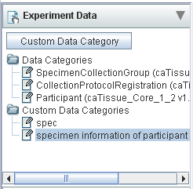
Figure 3.48. Custom Data Category
The Create Custom Data Category Panel appears.
- In the Custom Data Category Title field, provide the title.
- In the Data List field, select the data list.
- In the Category field, select the category.
- Select attributes from Available Attributes to be added in CDC.
- Click Add/Add All to add to Selected Attributes.
- Select attributes from the Selected Attributes and click Remove/Remove All button to remove the attributes from CDC.
- Click Save.
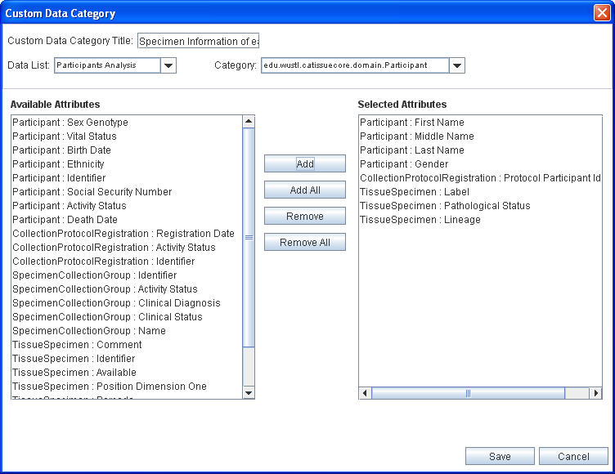
Figure 3.49. Custom Data Category Panel
The new CDC appears under Custom Data Categories section in Experiment Data box of the operations panel as shown below.
Saved Custom Data Category
Figure 3.50. Saved Custom Data Category

Visualizing Data
You can visualize the data in the experiment by using various graphical components such as charts and scatter plots. These options provide a graphical summary of the data allowing comparison, variation, and co-relational analysis of the data.
Some terms used:
Data series: Related data points plotted in a chart that originates from data rows or data columns. Each data series in a chart has a unique color or pattern represented by a Legend. You can plot one or more data series in a chart.
Legend: A small color box that identifies each series in the chart
The current version of caB2B supports following visualization options in Visualize Data box.
Visualize option | Description
 | This is a chart with rectangular bars of lengths proportional to the data value it represents
 | This is a chart with a line joining the points that represents data value
 | A scatter plot will show a linear or non-linear relationship between the variables (column selected). It also helps in finding outliers in the data.
Table 3.4. Types of charts supported

How to plot data series
- Select the data that you want to plot from Experiment tab.
- Click on the link for type of the chart you wanted from the Visualize Data Stack Box, for example
- It will open the chart in a new tab in right hand side panel.
- By default, data series are from columns on the Experiment Data tab. To change the data series toggle the radio buttons in the upper left corner of the chart area.

Following images represents the various charts for PubMed count for few Genes obtained from FE server.

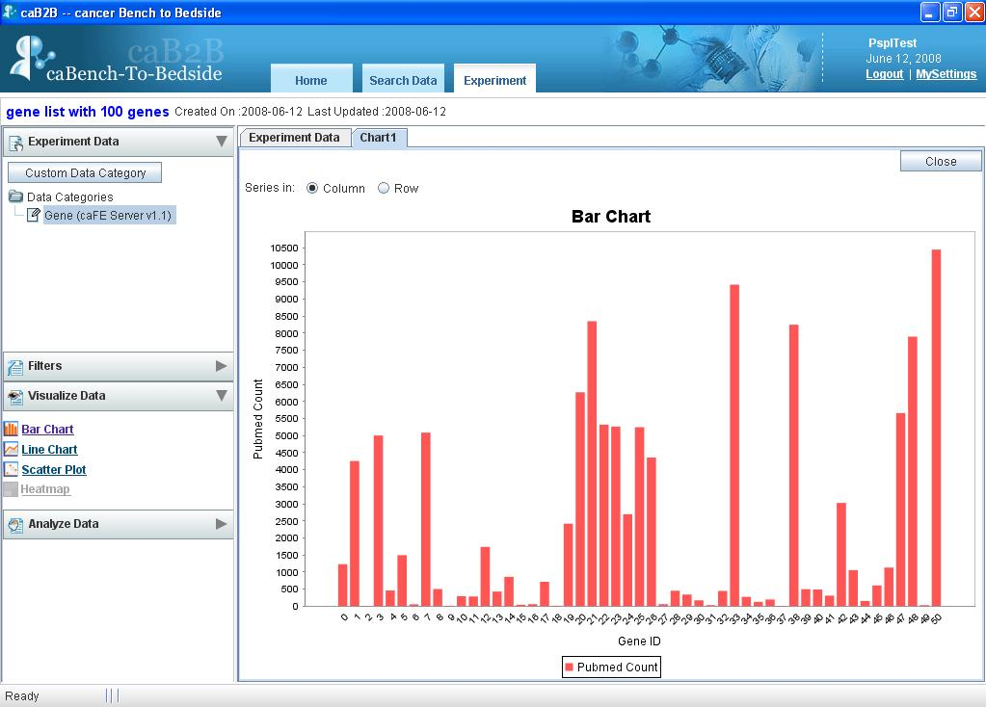
Figure 3.51. Bar chart example

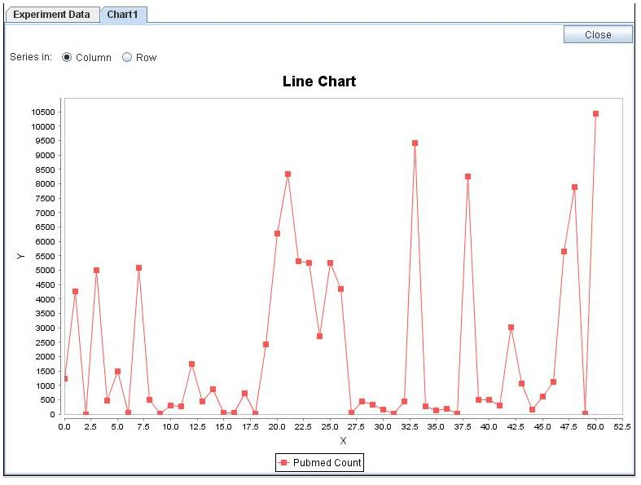
Figure 3.52. Line chart example
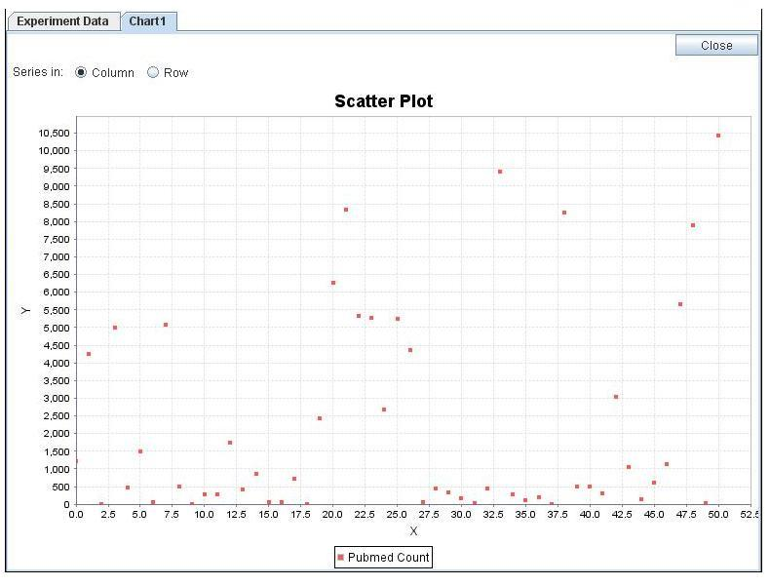
Figure 3.53. Scatter Plot example

How to change data series from rows to columns and vice versa?
You can configure whether data series are from rows or columns by selecting appropriate Series In options.
- To have the data columns to represent the data series, select option.
- To have the data rows to represent the data series, select option.

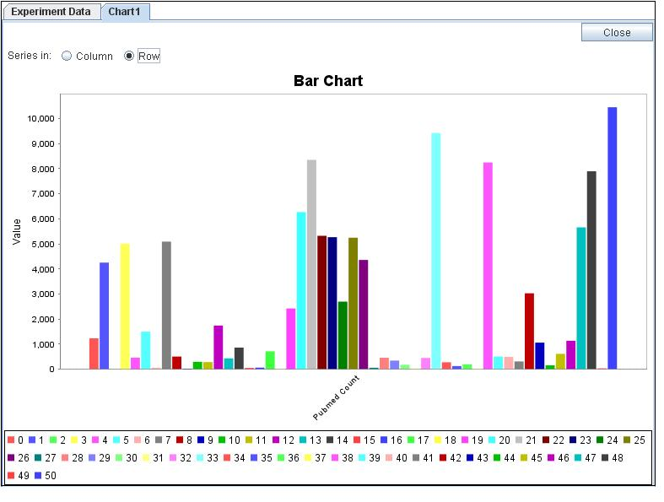
Figure 3.54. Bar chart with data series from rows
You can change the type of the chart that you are currently viewing by selecting required chart link from Visualize Data box.
You can create multiple charts for the data.
The name of the tab added for each chart is “chart” followed by a unique number for that chart. For example chart1, chart2, etc.

Examples of category search
This appendix provides examples of the advanced search strategies that are possible in caB2B, while searching for categories.

Text-based Search - For category name information
To search categories having “gene” in their name do the following:
- In the Search box, type gene.
- Expand the Advanced Search box
- Select the Category check box.
- Click Text.
- Click Search.

The results of this search are as shown below. All the categories shown below have gene in their names.
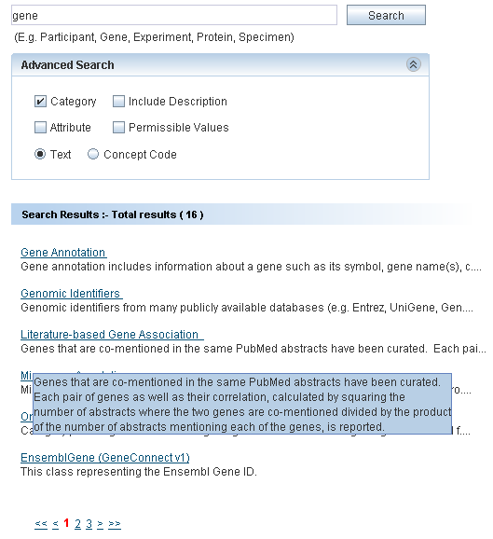
Figure A.1. Search Result of Example 1

Text-based Search - For category and attribute name and description
To search the categories having “Protein” in their name or description or to search the attributes having “Protein” in their name or description, you need to do following:
- In the Search box, type Protein
- Open Advanced Search box.
- Select the Category check box.
- Select the Attribute check box.
- Select the Include Description check box.
- The Text option button is selected by default.
- Click Search.

The result of this search is as shown in the screenshot below.
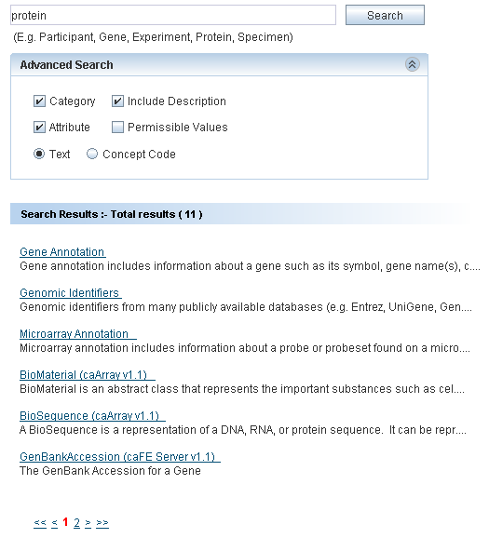
Figure A.2. Search Result of Example 2

Concept Code Based Search - For category name information
To search categories having concept code “c29867”:
- In the Search box, type c29867.
- Open the Advanced Search box.
- Select the Category check box.
- Select the Concept Code option button.
- Click Search.
The result of this search is as shown in the screenshot below.
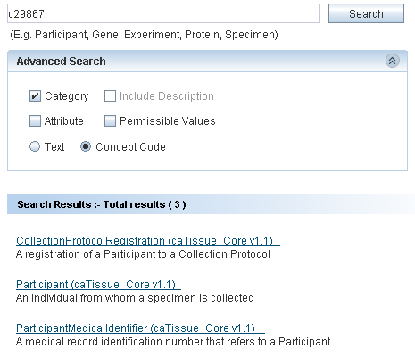
Figure A.3. Search Result of Example 3

Concept code based search - For attribute name information
To search categories whose attribute has concept code “C42614”:
- In the Search box, type C42614.
- Select the Attribute check box.
- Select the Concept Code option button.
- Click Search.

The result of this search is as shown in the screenshot below.
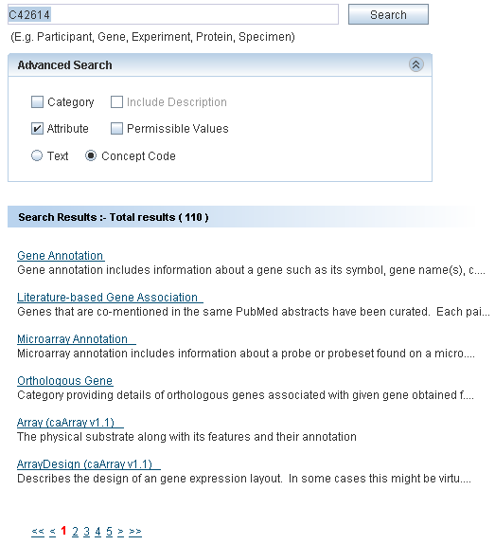
Figure A.4. Search Result of Example 4

Define Limit: Operators and Values
This appendix explains the various operators. It also explains how to specify values while defining limits on a category.
The following table explains the different operators and provides examples of the values to be specified:

Operator | Data types for which applicable | Sample condition | Expected Results
Equals | Numeric  Date  String | Name equals “John” | Returns only John and not john
Not equals | Numeric  Date  String | Identifier not equals 32 | Returns all records except those having identifier = 32
Less than | Numeric  Date | Participant’s birth date less than 2000/1/1 | Returns all Participants born before January 1st, 2000
Less than or equal | Numeric  Date | Signal value less than or equals to 0.5 | Returns all records for which signal value is not more than 0.5
Greater than | Numeric  Date | Cell count is greater than 10000 | Returns all records with Cell count > 10000
Greater than or equals | Numeric  Date | Specimen’s collection-date greater than or equal to 2005/5/1 | Returns all specimens collected on or after May 1st, 2005
Between | Numeric  Date | Patient’s admission date between 2000/1/1 and 2000/12/31 | Returns all Patients admitted in the year 2000
Is null | Numeric  String  Date | Patient’s contact number is null | Returns all patients who do not have any contact number
Is not null | Numeric  Date | Participant’ middle name is not null | Returns all Participants for whom middle name is specified
In | Numeric  String  Enumerated | - Signal value in 0.1,0.5,0.7,  - Name in “John”, ”john” | - Returns all records whose signal value is 0.1 or 0.5 or 0.7  - Returns both John and john
Not in | Numeric  String  Enumerated | Participant’s gender not in male, unspecified | Returns all participants whose gender is either not specified or gender is not male.
Starts with | String | Participant’s first name starts with Jo | Returns all participants whose first name starts with Jo like John, Jona  Does not return the participant with name Scott, Henry, Jen
Ends with | String | Participant’s last name ends with n | Returns all participants whose last name ends with n like John, Jon, and Jen Does not return participant with name Scott, Henry
Contains | String | Participant’s first name contains ann | Returns all participants whose first name is Joanna, Anna, and Johanna. Does not return participant with name Jen, Denny

- For attributes with enumerated values and Boolean attributes, clear a value by clicking on the value with the CTRL key pressed.
- If you use the In operator for a non-enumerated attribute, you can specify multiple values as follows:
- Separate multiple values using a comma. For example, to specify the constraint Identifier IN 2, 4, 5, 7, you should type the value as 2,4,5,7.
- If a value itself contains a comma, you can enclose the value in double quotes. For example, to specify the constraint Name IN “Einstein, Albert”, “Newton, Isaac” the value that you should enter is “Einstein, Albert”, “Newton, Isaac”.
- For attributes that requires a date value, you can click the icon to launch a date selector. You can also type a date string directly in the text box. The format of this string must be YYYY/MM/DD. A valid date string becomes green whereas an invalid date string turns red. System will ignore an invalid date string.

Record Details View

The details of a record usually consist of the values of the attributes of the category (See Figure 2.31. Results’ Details). This section provides examples of special categories that result in a slightly different view of the record’s details.

Administrator defined categories
The Administrator builds categories by manually grouping relevant attributes from one or more existing categories.
For each record of such a category, you can see the following information:
  - Values of the attributes in a table
  - Related information as a tree, the leaf nodes of this tree are attributes; you can see the values of those attributes in the tree.
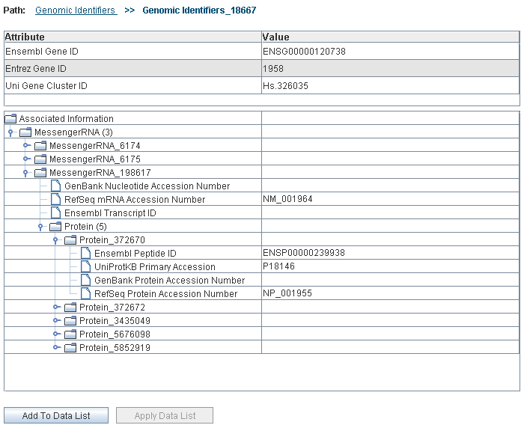
Figure C.1. One record of an administrator defined category (Genomic Identifiers)

Types of Filters
A filter is shown when you choose to filter the data of a data-category (see How to filter data).
The type of filter depends on the column based on which you wish to filter data.
Table D.1: Column Type and Applicable Filter
Data type of the column | Applicable filter
Numeric | Range filter
Text | Pattern filter
Column with permissible values | Enumerated filter
Boolean | Enumerated filter

Using the Range Filter
The system shows a Range Filter if the column selected as a basis for the filter has numeric values. It allows you to select the desired minimum and maximum values of the column.
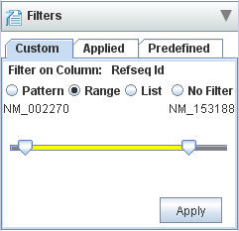
Figure D.1. Set Filter for Range

There are two sliders, the left slider and the right slider. The two ends show the value denoted by each slider.
- Position the left slider to the minimum value desired.
- Position the right slider to the maximum value desired.
- Click Apply to apply the filter.

Using the Pattern Filter
The system shows a Pattern Filter if the column selected as a basis for the filter has text values. It allows you to specify a pattern that the values of that column should satisfy.
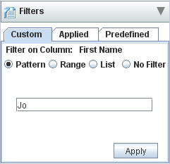
Figure D.2. Pattern Filter
In the text field, type the desired pattern and click Apply.

Using the Enumerated Values Filter
The system shows a List Filter if the column selected as a basis for the filter has a set of permissible values. It allows you to specify the values that the column should satisfy.
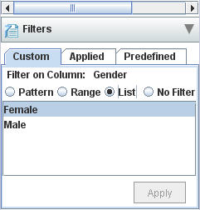
Figure D.3. Enumerated Values Filter for the column gender
Select the desired permissible values and click Apply.

Index

Administrator defined category, 67
Advanced search, 15
Ambiguity resolver, 22
Apply Data List, 37
Breadcrumbs, 37
caB2B, 1, 3
caBench-to-Bedside. See caB2B, See caB2B
CDC, 54
Concept code, 16
Creating Experiments, 46
Custom Data Category
creating, 54
definition, 54
Data
filtering, 46, 50, 51
visualizing, 46, 50, 56
Data List, 13, 42, 46
Saving, 44
Define Search Results View, 13, 24
Editing filters, 52
Executing saved query, 32
Experiment Details page, 49
Operations panel, 50
Visualization panel, 50
Experiments
creating, 46
definition, 46
opening, 46, 49
viewing, 48
Filters
editing, 52
enumerated value, 70
pattern, 70
range, 69
removing, 53
saving, 46, 50, 53
types, 69
Limits
connecting, 20
DAG, 18
defining, 13, 16, 19, 25
definition, 12
deleting, 20
editing, 19
information panel, 23
Login, 3, 4
My Data List Summary, 28, 30, 31, 32, 37
Opening Experiments, 46, 49
Path, 20
Plotting data series, 56
Projects, 46
Query
definition, 12
executing, 32
saving, 13, 29
Query Wizard, 13, 46
Related data, 36
Removing filters, 53
Save query
advantages, 29
executing, 32
non-parameterized, 30
Search categories, 60
Spreadsheet view, 49
View Search Results, 13, 34
Viewing Experiments, 48
Vizualise data, 46, 50, 56
Vizualize data
bar chart, 56, 57
line chart, 56, 58
scatter plot, 56, 58

